GAMMING ROOM

**A Skill Oriented Course Web Application report**

Submitted in the partial fulfilment of the requirements for

the award of the degree of

Bachelor of Technology

In

Computer Science and Engineering

by

**BODDU YASWANTH**

**21761A0577**

Under the guidance of

Dr. K. Devi Priya,

Associate Professor, Dept. of CSE



**Department of Computer Science and Engineering**

**Lakireddy Bali Reddy College of Engineering (Autonomous)**

**Accredited by NAAC & NBA (Under Tier - I)**

**Affiliated to JNTUK, Kakinada; ISO 9001:2015 Certified**

**2022-23**

|  |  |
| --- | --- |
|  | **LAKIREDDY BALI REDDY COLLEGE OF ENGINEERING**  **(AUTONOMOUS)**  **Accredited by NAAC with ‘A’ Grade & NBA (Under Tier - I), ISO 9001:2015 Certified Institution**  **Approved by AICTE, New Delhi and Affiliated to JNTUK, Kakinada**  **L.B. REDDY NAGAR, MYLAVARAM, NTR DIST., A.P.-521 230.**  [hodcse@lbrce.ac.in,](mailto:hodcse@lbrce.ac.in,%20) [cseoffice@lbrce.ac.in,](mailto:cseoffice@lbrce.ac.in,%20) Phone: 08659-222933, Fax: 08659-222931  **DEPARTMENT OF COMPUTER SCIENCE &ENGINEERING** |

**Certificate**

This is to certify that the 20CSS2-Web Application Development using Full Stack Module-II (Backend Development) Skill Oriented Course entitled “**Gamming Room**” is being submitted by **BODDU YASWANTH , 21761A0577** in partial fulfilment for the award of B. Tech in Computer Science & Engineering to the Jawaharlal Nehru Technological University Kakinada is a record of bonafide work carried out by her/him under my guidance.

The results embodied in this Skill Oriented Course Web Application / Project report have not been submitted to any other University or Institute for the award of any degree or diploma.

**Project Guide Head of the department**

Dr. K Devi Priya Dr. D. Veeraiah,

Associate Professor. Professor.

**External Examiner**

**ACKNOWLEDGEMENT**

I would like to thank **Dr. K. Devi Priya,** Associate Professor**,** CSE department for the encouraging and support in carrying out this Skill Oriented Course Web Application.

I also take the privilege to record my thanks to **Dr. D. Veeraiah,** Professor, Head of the Department of CSE whose encouragement, cooperation and valuable support crown my success.

I express my thanks to the support given by management in completing my Web Application / Project. I also express my sincere gratitude & deep sense of respect to the Principal, **Dr.K. Appa Rao** for making us available all the required assistance and his support and inspiration to carry out this Skill Oriented Course Web Application / Project in the Institute.

I am thankful to the teaching and non-teaching staff of CSE department for their direct as well as indirect help in my Skill Oriented Course Web Application / Project.

I am elated to avail my selves to this opportunity to express my deep sense of gratitude to my parents.

**ABSTRACT**

This research paper aim is to develop a Gamming Website. It's an online play game where anyone can download and play the online game using this website and application. This system will help the users to download the mobile games, pc games, xbox games etc when needed. They can also find latest games launched here. Users can also play user friendly games etc. directly using thi­s system in a cheaper way. This System has web-based interface. Users can use according to their purpose. In my project there are several sections for the customer to visit my page, they are home page, menu page, About us page, registration page, mobile page, pc page, xbox page and User login page.

Account section will consist of login and register pages, login page will let user to login the user with their email and password. I any new user wants to create an account they will redirected to the register page where user can enter their name, email and password to create a new account. This system can be a one stop solution for all zoner Games.

**CONTENTS**

**CONCEPTS Page No**

1. Introduction
2. Modules(Include usecase and class Diagram)
3. Technologies Used
   * 1. HTML
     2. CSS
     3. JDBC
     4. JSP / SERVLETS
4. Implementation
5. HTML Code
6. List of Database Tables(Constraints, Normalization)
7. Back-end code
8. Testing(Validations)
9. Screen Shots
10. Conclusion
11. Web References

**1.Introduction**

Welcome to our gaming Room website, your ultimate destination for all things gaming! We are a premier online platform dedicated to providing an immersive and thrilling gaming experience for players of all levels and interests.

Our website offers a vast collection of games from various genres, including action, adventure, strategy, sports, and more. Whether you're a hardcore gamer looking for intense competition or a casual player seeking some relaxation, we have something for everyone.

With our user-friendly interface, you can easily navigate through our extensive game library and discover new titles or revisit old favorites. We prioritize quality and strive to offer only the best games, ensuring that your gaming sessions are enjoyable and memorable.

Stay up-to-date with the latest releases, industry trends, and gaming events through our dedicated news section.

Safety and security are paramount to us, and we maintain strict measures to ensure a safe gaming environment. Our website is protected with robust encryption technology, and we strictly adhere to privacy regulations to safeguard your personal information.

Whether you're a console enthusiast, PC gamer, or mobile gamer, our gaming website caters to all platforms, providing a seamless gaming experience across devices.

So, dive into the world of gaming with our website and let the adventure begin! Join our community, explore our games, and unlock endless fun and excitement. Get ready to embark on a gaming journey like no other!

**2. Modules:**

Modules used in this website are:

**Home Module:**  In the home page module, it contains moblie page, pc page, xbox page, about page, contact us page and also contains profile page.

**Login Module:** In the login page module, user can login into website and user can change their password if they forget their password and that will be updated into database.

**Register Module:**  In the registration page, the user needs to register if he doesn’t has an existing account in the website and it contains four values in the form.

**Admin Dashboard:** In the admin dashboard page ,it contains details of all the users registered in the website.

*Use case Diagram :*

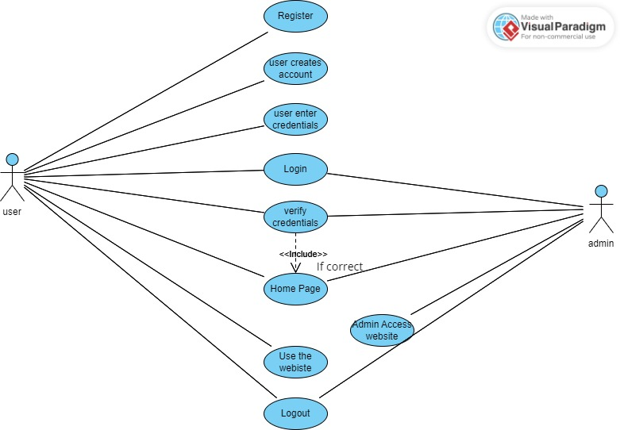

*Sequence diagram:*

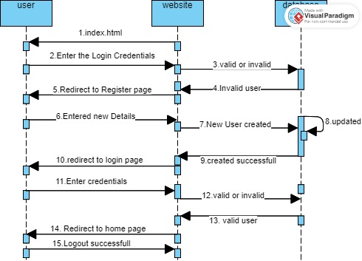

**3. TECHNOLOGIES USED:**

3.1 HTML:

## Hyper Text Markup Language (HTML)

**HTML** stands for Hyper Text Markup Language. It is used to design web pages using a markup language. HTML is the combination of Hypertext and Markup language. Hypertext defines the link between web pages. A markup language is used to define the text document within the tag which defines the structure of web pages. This language is used to annotate (make notes for the computer) text so that a machine can understand it and manipulate text accordingly. Most markup languages (ex: HTML) are human-readable. The language uses tags to define what manipulation has to be done on the text.

HTML is a markup language used by the browser to manipulate text, images, and other content, in order to display it in the required format. HTML was created by Tim Berners-Lee in 1991. The first-ever version of HTML was HTML 1.0, but the first standard version was HTML

2.0, published in 1995.

**Features of HTML:**

* It is easy to learn and easy to use.
* It is platform-independent.
* Images, videos, and audio can be added to a web page.
* Hypertext can be added to the text.
* It is a markup language.

**Advantages:**

* HTML is used to build websites.
* It is supported by all browsers.
* It can be integrated with other languages like CSS, JavaScript, etc.

Example:

<!DOCTYPE html>  
<html>  
<head>  
<title>Page Title</title>  
</head>  
<body>  
  
<h1>My First Heading</h1>  
<p>My first paragraph.</p>  
  
</body>  
</html>

### **Example Explained**

* The <!DOCTYPE html> declaration defines that this document is an HTML5 document
* The <html> element is the root element of an HTML page
* The <head> element contains meta information about the HTML page
* The <title> element specifies a title for the HTML page (which is shown in the browser's title bar or in the page's tab)
* The <body> element defines the document's body, and is a container for all the visible contents, such as headings, paragraphs, images, hyperlinks, tables, lists, etc.
* The <h1> element defines a large heading
* The <p> element defines a paragraph

## What is an HTML Element?

An HTML element is defined by a start tag, some content, and an end tag:

<tagname> Content goes here... </tagname>

The HTML **element** is everything from the start tag to the end tag:

<h1>My First Heading</h1>

<p>My first paragraph</p>

|  |  |  |
| --- | --- | --- |
| Start Tag | Element content | End Tag |
| <h1> | My First Heading | </h1> |
| <p> | My First paragraph | </p> |
| <br> | None | None |

**Web Browsers**

The purpose of a web browser (Chrome, Edge, Firefox, Safari) is to read HTML documents and display them correctly.

A browser does not display the HTML tags, but uses them to determine how to display the document:

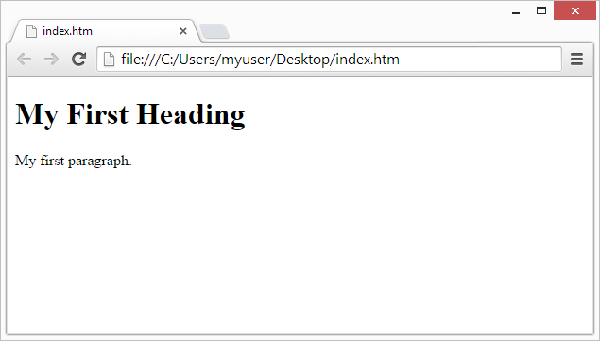

## HTML Page Structure

Below is a visualization of an HTML page structure:

<html>

<head>

<title>Page title</title>

</head>

<body>

<h1>This is a heading</h1>

<p>This is a paragraph.</p>

<p>This is another paragraph.</p>

</body>

</html>

**HTML Tables**:

The HTML tables allow web authors to arrange data like text, images, links, other tables, etc. into rows and

columns of cells.

The HTML tables are created using the<table> tag in which the <tr>tag is used to create table rows

and <td> tag is used to create data cells.

**Table Heading:**

Table heading can be defined using <th> tag. This tag will be put to replace <td> tag, which is used to represent actual data cell. Normally you will put your top row as table heading as shown below, otherwise you can use <th>

element in any row.

**Cell padding and Cell spacing Attributes:**

There are two attributes called cell padding and cell spacing which you will use to adjust the white space in your table cells. The cell spacing attribute defines the width of the border, while cell padding represents the distance between cell borders and the content within a cell.

**Colspan and Rowspan Attributes:**

You will use Colspan attribute if you want to merge two or more columns into a single column. Similar way you will use rowspan if you want to merge two

or more rows.

**Table Header, Body, and Footer:**

Tables can be divided into three portions : a header, a body, and a foot. The head and foot are rather similar to headers and footers in a word-processed document that remain the same for every page, while the body is the main content holder of the table.

The three elements for separating the head, body, and foot of a table are: • <thead> - to create a separate table header.

• <tbody> - to indicate the main body of the table.

> <tfoot>- to create a separate table footer.

A table may contain several <tbody> elements to indicate different pages or groups of data.

But it is notable that <thead> and <tfoot> tags should appear before <tbody>

**HTML Forms:**

HTML Forms are required when you want to collect

some data from the site visitor. For example during user registration you would like to collect information such as name, email address, credit card, etc.

A form will take input from the site visitor and then will post it to a back-end application such as CGI, ASP Script, or PHP script etc. The back-end application will perform required processing on the passed data based on defined business logic inside the application. There are various form elements available like text fields, text area fields, drop-down menus,

radio buttons, check boxes, etc.

**Password input controls:-**

This is also a single-line text input, but it masks the character as soon as a user enters it. They are also created by using HTML <input> tag but type attribute is set to password.

**Multiple-Line Text Input Controls:-**

This is used when the user is required to give details that may be longer than a single sentence. Multi-line input controls are created using HTML <text area> tag.

Checkbox Control

Check boxes are used when more than one option is required to be selected. They are also created using HTML <input> tag but type attribute is set to checkbox..

**Radio Button Control:-**

Radio buttons are used when out of many options, just one option is required to be selected. They are also created using HTML <input> tag but type attribute is set to radio.

**Select Box Control:-**

A select box, also called drop down box which provides option to list down various options in the form of drop down list, from where a user can select one or more options.

**Button Controls:-**

There are various ways in HTML to create clickable buttons. You can also create a clickable button using <input> tag by setting its type attribute to button ( submit, reset, button, image ).

**HTML Frames:-**

HTML frames are used to divide your browser window into multiple sections where each section can load a separate HTML document. A collection of frames in the browser window is known as a frame set. The window is divide into frames in a similar way the tables are organized: into rows and columns

To use frames on a page we use <frameset> tag instead of <body> tag. The <frameset> tag defines how to divide the window into frames. The rows attribute of <frameset> tag defines horizontal frames and cols attribute defines vertical frames. Each frame is indicated by <frame> tag and it defines which HTML document shall open into the frame.

**The <frameset> Tag Attributes:**

Following are important attributes of the <frameset> tag:

**Cols:**

specifies how many columns are contained in the frameset and the size of each column. You can specify the width of each column in one of four ways: • Absolute values in pixels. For example to create three vertical frames, use cols="100, 500,100".

This attribute works just like the cols attribute and takes the same values, but it is used to specify the rows in the frameset. For example to create two horizontal frames, use rows="10%, 90% ". You can specify the height of each row in the same way as explained above for columns.

**Border:**

This attribute specifies the width of the border of each frame in pixels. For example border="S". A value of zero means no border.

**Frame border:**

This attribute specifies whether a three-dimensional border should be displayed between frames. This attribute takes value either 1 (yes) or 0 (no). For example frame border="0" specifies no border.

**Frame spacing:**

This attribute specifies the amount of space between frames in a frameset. This can take any integer value. For example frame spacing="10" means there should be 10 pixels spacing between each frames.

3.2 CSS :

## Cascading Style Sheets (CSS)

**C**ascading **S**tyle **S**heets, fondly referred to as **CSS**, is a simply designed language intended to simplify the process of making web pages presentable. CSS allows you to apply styles to web pages. More importantly, CSS enables you to do this independent of the HTML that makes up each web page. It describes how a webpage should look: it prescribes colors, fonts, spacing, and much more. In short, you can make your website look however you want. CSS lets developers and designers define how it behaves, including how elements are positioned in the browser.

While html uses tags, CSS uses rulesets. CSS is easy to learn and understand, but it provides powerful control over the presentation of an HTML document.

Advantages of CSS:

* **CSS saves time:** You can write CSS once and reuse the same sheet in multiple HTML pages.
* **Easy Maintenance:** To make a global change simply change the style, and all elements in all the webpages will be updated automatically.
* **Search Engines:** CSS is considered a clean coding technique, which means search engines won’t have to struggle to “read” its content.
* **Superior styles to HTML:** CSS have a much wider array of attributes than HTML, so you can give a far better look to your HTML page in comparison to HTML attributes.
* **Offline Browsing:** CSS can store web applications locally with the help of an offline cache. Using this we can view offline websites.

## Why Use CSS?

CSS is used to define styles for your web pages, including the design, layout and variations in display for different devices and screen sizes.

<!DOCTYPE html>

<html>

<head>

<style>

body {

background-color: lightblue;

}

h1 {

color: white;

text-align: center;

}

p {

font-family: verdana;

font-size: 20px;

}

</style>

</head>

<body>

<h1>My First CSS Example</h1>

<p>This is a paragraph.</p>

</body>

</html>

## CSS Solved a Big Problem

HTML was NEVER intended to contain tags for formatting a web page!

HTML was created to describe the content of a web page, like:

<h1>This is a heading</h1>

<p>This is a paragraph.</p>

When tags like <font>, and color attributes were added to the HTML 3.2 specification, it started a nightmare for web developers. Development of large websites, where fonts and color information were added to every single page, became a long and expensive process.

To solve this problem, the World Wide Web Consortium (W3C) created CSS.

CSS removed the style formatting from the HTML page!

## CSS Syntax

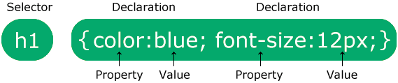

The selector points to the HTML element you want to style.

The declaration block contains one or more declarations separated by semicolons.

Each declaration includes a CSS property name and a value, separated by a colon.

Multiple CSS declarations are separated with semicolons, and declaration blocks are surrounded by curly braces.

CSS Saves a Lot of Work!

The style definitions are normally saved in external .css files.

With an external stylesheet file, you can change the look of an entire website by changing just one file!

: CSS Selectors

CSS selectors are used to "find" (or select) HTML elements based on their element name, id and class.

**The element Selector:**

The element selector selects elements based on the element name. You can select all <p> elements on a page like this (in this case, all <p> elements will be center-aligned, with a red text color):

**The id Selector:**

• The id selector uses the id attribute of an HTML element to select a specific element.

The id of an element should be unique within a page, so the id selector is used to select one unique element!

• To select an element with a specific id, write a hash (#) character, followed

by the id of the element.

**The class Selector:**

• The class selector selects elements with a specific class attribute.

• To select elements with a specific class, write a period (.) character, followed by the name of the class.

Three Ways to Insert CSS (Types of CSS):

There are three ways of inserting a style sheet:

• External style sheet

• Internal style sheet

Inline style Inline Styles

**Inline Styles:**

* An inline style may be used to apply a unique style for a single element.
* To use inline styles, add the style attribute to the relevant element. The style attribute can contain any CSS property.

**Internal Style Sheet:**

* An internal style sheet may be used if one single page has a unique style.
* Internal styles are defined within the <style> element, inside the <head> section of an HTML page:

.

**External Style Sheet:**

• With an external style sheet, you can change the look of an entire website by changing just one file!

• Each page must include a reference to the external style sheet file inside the

<link> element. The <link> element goes inside the <head> section:

**Cascading Order:**

What style will be used when there is more than one style specified for an HTML element?

Generally speaking we can say that all the styles will "cascade" into a new

"virtual" style sheet by the following rules, where number one has the highest priority:

1. Inline style (inside an HTML element)

2. External and internal style sheets (in the head section)

3. Browser default

So, an inline style (inside a specific HTML element) has the highest priority, which means that it will override a style defined inside the <head> tag, or in

an external style sheet, or a browser default value.

CSS Properties:

Text Properties:

• color: blue;

⚫ text-align: center/left/right/justify;

⚫ text-decoration: over line/line-through/underline;

⚫ text-transform: uppercase/lowercase/capitalize;

⚫ text-indent: 10px/-10px;

⚫ letter-spacing: 5px/-5px;

* line-height: 0.8;
* direction: rtl;
* word-spacing: 10px;
* text-shadow: 3px 2px red;

**Font Properties:**

1. font-family: arial;

2. font-style: normal/italic/oblique;

3. font-size: 30px;

4. font-weight: normal/bold;

5. font-variant: normal/small-caps;

**Border Properties:**

1.border style:

dotted/dashed/solid/double/groove/ridge/inset/outset/none/hidden.

2. border-width: 5px; border-width: 2px 10px 4px 20px.

3. border-color: red; Border-color: red, green blue yellow;

Note: four values indicate - first for top border, second for right border,

third for bottom border, fourth for left border.

**Background Properties:**

* background-color: red.
* background-image: URL ("image path");
* background-repeat: repeat-x/repeat-y/round/no-repeat.

⚫ background-attachment: fixed/scroll/local.

background-size: 20px 30px.

⚫ background-position: right top/right bottom/left top/left bottom.

or 30px,20px.

**Margin Properties:**

⚫ margin-top: 100px.

* margin-bottom: 100px.
* margin-right: 150px.
* margin-left:80px.

**Link Properties:**

* a: link- uninvited link
* a: hover-when mouse is on it
* a: active- when mouse click on it
* a: visited-after mouse clicked

**Layouts:**

**HTML Layout Elements**

Websites often display content in multiple columns (like a magazine or newspaper).

HTML5 offers new semantic elements that define the various parts of a web page:

* <header>- Defines a header for a document or a section
* <nav>- Defines a container for navigation links
* <section>- Defines a section in a document
* <article> Defines an independent self-contained article

**JAVASCRIPT:**

JavaScript can be implemented using JavaScript statements that are placed within the <script>...

</script> HTML tags in a web page.

<script ...>

// JavaScript code

</script>

JavaScript in external file:

<html>

<head>

<script type="text/javascript" src="filename.js" ></script>

</head> </body> </html>

JavaScript Display Possibilities

* Writing into an HTML element, using inner HTML.
* Writing into the HTML output using document. Write ()
* Writing into an alert box, using window. alert ()
* Writing into the browser console, using console. Log ()

JavaScript Variables

Syntax: var variable name;

* Variables may hold different datatypes like string, array, Boolean, number, object.
* We can also use operators between the variables like addition, assignment, division etc.
* The main advantage of JavaScript is the form validation. If we won’t enter the details in the required fields in the form when we click the submit it alert a message through JavaScript.
* alert() - We use alert function to display the message in the window

We should write a code in a function and include that function in the body of the html document like as below

<body>

<form name="form name" onsubmit="return function name ();">

</body>

**3.3 JDBC :**

**1.Making a connection to a database :**

There are 5 steps to connect any java application with the database using JDBC. These steps are as follows:

**1.Register the Driver class:**

The forName() method is used to register the driver class.

**2. Create connection:**

The getConnection() method of DriverManager class is used to establish connection with the database.

**3. Create statement :**

The createStatement() method of Connection interface is used to create statement. The object of statement is responsible to execute queries with the database.

**4. Execute queries:**

The executeQuery() method of Statement interface is used to execute queries to the database. This method returns the object of ResultSet that can be used to get all the records of a table

1. **Close connection:**

By closing connection object statement and ResultSet will be closed automatically. The close() method of Connection interface is used to close the connection.

**2.  Creating SQL statements:**

To connect Java application with the ORACLE database, we need to follow 4 following steps.

 In this example we are using Oracle10g as the database. So we need to know following information for the oracle database:

**1.Driver class:** The driver class for the oracle database is            **oracle. jdbc. driver. OracleDriver.**

**2. Connection URL:** Connection URL: The connection URL for the oracle10G   database is **jdbc:oracle:thin:@localhost:1521:xe** where jdbc is the API, oracle is the database, thin is the driver, localhost is the server name on which oracle is running, we may also use IP address, 1521 is the port number and XE is the Oracle service name.

**3.Username**: The default username for the oracle database is system.

**4**. **Password:** It is the password given by the user at the time of installing the oracle database

**3. Executing SQL queries in the database:**

Once the connection was established, we have a Connection object, which can be used to create statements in order to execute SQL queries

**3.4 SERVLET:**

Servlet technology is used to create web application (resides at server side and generates dynamic webpage).

## Servlet API

* The javax.servlet and javax.servlet.http packages represent interfaces and classes for servlet API.
* The javax.servlet package contains many interfaces and classes that are used by the servlet or web container. These are not specific to any protocol.
* The javax.servlet.http package contains interfaces and classes that are responsible for http requests only.

## Life Cycle of a Servlet (Servlet Life Cycle)

The web container maintains the life cycle of a servlet instance. Let's see the life cycle of the servlet:

1. Servlet class is loaded.
2. Servlet instance is created.
3. init method is invoked.
4. service method is invoked.
5. destroy method is invoked.

## 1) Servlet class is loaded

The classloader is responsible to load the servlet class. The servlet class is loaded when the first request for the servlet is received by the web container**.**

## 2) Servlet instance is created

The web container creates the instance of a servlet after loading the servlet class. The servlet instance is created only once in the servlet life cycle.

## 3) init method is invoked

The web container calls the init method only once after creating the servlet instance. The init method is used to initialize the servlet. It is the life cycle method of the javax.servlet.Servlet interface. Syntax of the init method is given below:

public void init(ServletConfig config) throws ServletException

## 4) service method is invoked

The web container calls the service method each time when requestfor the servlet is received. If servlet is not initialized, it follows the first three steps as described above then calls the service method. If servlet is initialized, it calls the service method.

Notice that servlet is initialized only once. The syntax of the service method of the Servlet interface is given below: public void service(ServletRequest request, ServletResponse response) throws ServletException, IOException

## 5) destroy method is invoked

The web container calls the destroy method before removing the servlet instance from the service. It gives the servlet an opportunity to clean up any resource for example memory, thread etc. The syntax of the destroy method of the Servlet interface is given below: public void destroy()

## Steps to create a servlet example

There are given 6 steps to create a servlet example. These steps are required for all the servers.

The servlet example can be created by three ways:

1. By implementing Servlet interface,
2. By inheriting GenericServlet class, (or)
3. By inheriting HttpServlet class

Here, we are going to use apache tomcat server in this example. The steps are as follows:

1. Create a directory structure
2. Create a Servlet
3. Compile the Servlet
4. Create a deployment descriptor
5. Start the server and deploy the project
6. Access the servlet

## 1)Create a directory structures

The directory structure defines that where to put the different types of files so that web container may get the information and respond to the client.

The Sun Microsystem defines a unique standard to be followed by all the server vendors. Let's see the directory structure that must be followed to create the servlet.

## 2) Create a Servlet

There are three ways to create the servlet.

1. By implementing the Servlet interface
2. By inheriting the GenericServlet class
3. By inheriting the HttpServlet class

## 3) Compile the servlet

For compiling the Servlet, jar file is required to be loaded. Different Servers provide different jar files:

|  |  |
| --- | --- |
| **Jar file** | **Server** |
| servlet-api.jar | Apache Tomcat |
| weblogic.jar | Weblogic |
| javaee.jar | Glassfish |
| javaee.jar | JBoss |

## Two ways to load the jar file

1. set classpath
2. paste the jar file in JRE/lib/ext folder

Put the java file in any folder. After compiling the java file, paste the class file of servlet in WEB- INF/classes directory.

## 4) Create the deployment descriptor (web.xml file)

The deployment descriptor is an xml file, from which Web Container gets the information about the servlet to be invoked.The web container uses the Parser to get the information from the web.xml file. There are many xml parsers such as SAX, DOM and Pull.There are many elements in the web.xml file. Here is given some necessary elements to run the simple servlet program.

Description of the elements of web.xml file

There are too many elements in the web.xml file. Here is the illustration of some elements that is used in the above web.xml file. The elements are as follows:

<web-app> represents the whole application.

<servlet> is sub element of <web-app> and represents the servlet.

<servlet-name> is sub element of <servlet> represents the name of the servlet. <servlet-class> is sub element of <servlet> represents the class of the servlet.

<servlet-mapping> is sub element of <web-app>. It is used to map the servlet. <url-pattern> is sub element of <servlet-mapping>. This pattern is used at client side to invoke the servlet.

## 5) Start the Server and deploy the project

To start Apache Tomcat server, double click on the startup.bat file under apachetomcat/bin directory.

# 3.4 JSP:

## JSP Basics

JSP technology is used to create web application just like Servlet technology. It can be thought of as an extension to servlet because it provides more functionality than servlet such as expression language, jstl etc. A JSP page consists of HTML tags and JSP tags. The jsp pages are easier to maintain than servlet because we can separate designing and development. It provides some additional features such as Expression Language, Custom Tag etc.

Advantage of JSP over Servlet

There are many advantages of JSP over servlet. They are as follows:

## 1) Extension to Servlet

JSP technology is the extension to servlet technology. We can use all the features of servlet in JSP. In addition to, we can use implicit objects, predefined tags, expression language and Custom tags in JSP that makes JSP development easy.

## 2) Easy to maintain

JSP can be easily managed because we can easily separate our business logic with presentation logic. In servlet technology, we mix our business logic with the presentation logic.

**3) Fast Development:**

No need to recompile and redeploy

If JSP page is modified, we don't need to recompile and redeploy the project. The servlet code needs to be updated and recompiled if we have to change the look and feel of the application.

## 4) Less code than Servlet

In JSP, we can use a lot of tags such as action tags, jstl, custom tags etc. that reduces the code. Moreover, we can use EL, implicit objects etc.

Life cycle of a JSP Page

The JSP pages follows these phases:

* Translation of JSP Page o Compilation of JSP Page
* Classloading (class file is loaded by the classloader)
* Instantiation (Object of the Generated Servlet is created). o Initialization ( jspInit() method is invoked by the container).
* Reqeust processing ( _jspService() method is invoked by the container). o Destroy ( jspDestroy() method is invoked by the container).

## Creating a simple JSP Page

To create the first jsp page, write some html code as given below, and save it by .jsp extension. We have save this file as index.jsp. Put it in a folder and paste the folder in the web-apps directory in apache tomcat to run the jsp page. **index.jsp**

Let's see the simple example of JSP, here we are using the scriptlet tag to put java code in the JSP page.

We will learn scriptlet tag later.

<html>

<body> <% out.print(“welcome to JSP”); %>

</body>

</html>

It will print welcome to JSP on the browser.

How to run a simple JSP Page?

Follow the following steps to execute this JSP page: o Start the server

* put the jsp file in a folder and deploy on the server
* visit the browser by the url http://localhost:8080/folder/programname.jsp

## JSP Scripting elements

The scripting elements provides the ability to insert java code inside the jsp. There are three types of scripting elements: o scriptlet tag o expression tag o declaration tag

## JSP scriptlet tag

A scriptlet tag is used to execute java source code in JSP. Syntax is as follows:

<% java source code %>

## JSP expression tag

The code placed within JSP expression tag is written to the output stream of the response. So you need not write out.print() to write data. It is mainly used to print the values of variable or method.

## Syntax of JSP expression tag

<%= statement %>

In expression tag statement should not end with semicolon.

## JSP Declaration Tag

The JSP declaration tag is used to declare fields and methods.

The code written inside the jsp declaration tag is placed outside the service() method of auto generated servlet.

So it doesn't get memory at each request.

## Syntax of JSP declaration tag

The syntax of the declaration tag is as follows:

<%! field or method declaration %>

## JSP Implicit Objects

There are 9 jsp implicit objects. These objects are created by the web container that are available to all the jsp pages.

The available implicit objects are out, request, config, session, application etc.

## 1)JSP out implicit object

For writing any data to the buffer, JSP provides an implicit object named out. It is the object of JspWriter.

In case of servlet you need to write:

PrintWriter out=response.getWriter();

But in JSP, you don't need to write this code.

## 2) JSP request implicit object

The JSP request is an implicit object of type HttpServletRequest i.e. created for each jsp request by the web container. It can be used to get request information such as parameter, header information, remote address, server name, server port, content type, character encoding etc. It can also be used to set, get and remove attributes from the jsp request scope.

## 3) JSP response implicit object

In JSP, response is an implicit object of type HttpServletResponse. The instance of HttpServletResponse is created by the web container for each jsp request. It can be used to add or manipulate response such as redirect response to another resource, send error etc.

## 4) JSP config implicit object

In JSP, config is an implicit object of type ServletConfig. This object can be used to get initialization parameter for a particular JSP page. The config object is created by the web container for each jsp page.

Generally, it is used to get initialization parameter from the web.xml file.

## 5) JSP application implicit object

In JSP, application is an implicit object of type ServletContext. The instance of ServletContext is created only once by the web container when application or project is deployed on the server. This object can be used to get initialization parameter from configuaration file (web.xml). It can also be used to get, set or remove attribute from the application scope. This initialization parameter can be used by all jsp pages.

## 6) session implicit object

In JSP, session is an implicit object of type HttpSession.The Java developer can use this object to set,get or remove attribute or to get session information.

## 7) pageContext implicit object

In JSP, pageContext is an implicit object of type PageContext class.The pageContext object can be used to set,get or remove attribute from one of the following scopes: o page o request o session o application

In JSP, page scope is the default scope.

**8) page implicit object:**

In JSP, page is an implicit object of type Object class.This object is assigned to the reference of auto generated servlet class. It is written as:

Object page=this;

For using this object it must be cast to Servlet type.

## 9) exception implicit object

In JSP, exception is an implicit object of type java.lang.Throwable class. This object can be used to print the exception. But it can only be used in error pages.It is better to learn it after page directive.

**4.Implementation:**

* 1. FRONT END CODES :

**Index Page:**

1. <!DOCTYPE html>
2. <html lang="en">
3. <head>
4. <meta charset="UTF-8">
5. <meta http-equiv="X-UA-Compatible" content="IE=edge">
6. <meta name="viewport" content="width=device-width, initial-scale=1.0">
7. <title>main page</title>
8. <link rel="stylesheet" href="https://cdnjs.cloudflare.com/ajax/libs/font-awesome/6.2.1/css/all.min.css"
9. integrity="sha512-MV7K8+y+gLIBoVD59lQIYicR65iaqukzvf/nwasF0nqhPay5w/9lJmVM2hMDcnK1OnMGCdVK+iQrJ7lzPJQd1w=="
10. crossorigin="anonymous" referrerpolicy="no-referrer" />
11. <style>
12. * {
13. box-sizing: border-box;
14. padding: 0px;
15. margin: 0px;
16. /* background: black; */
17. }
18. body {
19. background: url(img/pc/ass1.jpg);
20. background-repeat: no-repeat;
21. background-size: cover;
22. }
23. .mid-login {
24. margin: 100px;
25. display: inline-flex;
26. }
27. .mid-login a {
28. text-decoration: none;
29. }
30. .si {
31. margin: 30px;
32. padding: 20px;
33. background: rgb(74, 90, 231);
34. color: white;
35. border-radius: 50px;
36. }
37. .si:hover {
38. color: rgb(244, 62, 62);
39. box-shadow: 8px 5px 20px rgb(0, 0, 0);
40. }
41. .lo {
42. margin: 30px;
43. padding: 20px;
44. background: rgb(74, 90, 231);
45. color: white;
46. border-radius: 50px;
47. }
48. .lo:hover {
49. color: rgb(244, 62, 62);
50. box-shadow: 8px 5px 20px rgb(0, 0, 0);
51. }
52. footer {
53. position: fixed;
54. bottom: 0;
55. width: 100%;
56. height: 90px;
57. text-align: center;
58. color: rgb(255, 255, 255);
59. background-color: black;
60. font-size: 20px;
61. }
62. .footer-links a {
63. text-decoration: none;
64. color: white;
65. }
66. .footer-links a:hover {
67. color: red;
68. }
69. </style>
70. </head>
71. <body>
72. <main>
73. <a href="index.html" style="text-decoration: none;">
74. <li
75. style="color: rgb(212, 205, 205);font-size:30px;padding-left: -30px;text-shadow: 10px 5px 6px red;list-style: none;margin:30px ;">
76. Gamming
77. Room</li>
78. </a>
79. <div class="mid-login">
80. <h2 class="sign"> <a href="main_signup.html" class="si">Sign In</a></h2>
81. <h2 class="mid-log"> <a href="main_login.html" class="lo">Login</a></h2>
82. </div>
83. </main>
84. <footer>
85. <div class="links">
86. <a href="https://www.whatsapp.com/" target="_blank"><i class="fa-brands fa-square-whatsapp"></i></a> &nbsp;
87. <a href="https://www.facebook.com/" target="_blank"><i class="fa-brands fa-facebook"></i></a>&nbsp;
88. <a href="https://twitter.com/i/flow/login?input_flow_data=%7B%22requested_variant%22%3A%22eyJsYW5nIjoiZW4ifQ%3D%3D%22%7D"
89. target="_blank"><i class="fa-brands fa-twitter"></i></a>&nbsp;
90. </div>
91. <span> &copy; Gamming Room, 2022 All rights reserved </span>
92. <div class="footer-links">
93. <a href="main_login.html">Login</a>
94. &nbsp;&nbsp;|&nbsp;&nbsp;
95. <a href="main_signup.html">signup</a>
96. </div>
97. </footer>
98. </body>
99. </html>

Home page:

<%@ page import="java.sql.*" %>

    <!DOCTYPE html>

    <html lang="en">

    <head>

        <meta charset="UTF-8">

        <meta http-equiv="X-UA-Compatible" content="IE=edge">

        <meta name="viewport" content="width=device-width, initial-scale=1.0">

        <link rel="stylesheet" href="home.css">

        <link

            href="https://fonts.googleapis.com/css2?family=Martian+Mono:wght@200&family=Merriweather:wght@300&family=Rubik+Bubbles&family=Sevillana&display=swap"

            rel="stylesheet">

        <link rel="stylesheet" href="https://cdnjs.cloudflare.com/ajax/libs/font-awesome/6.2.1/css/all.min.css"

            integrity="sha512-MV7K8+y+gLIBoVD59lQIYicR65iaqukzvf/nwasF0nqhPay5w/9lJmVM2hMDcnK1OnMGCdVK+iQrJ7lzPJQd1w=="

            crossorigin="anonymous" referrerpolicy="no-referrer" />

        <link rel="stylesheet"

            href="https://fonts.googleapis.com/css2?family=Material+Symbols+Outlined:opsz,wght,FILL,GRAD@20..48,100..700,0..1,-50..200" />

        <link href="https://fonts.googleapis.com/css2?family=Caveat:wght@400;700&display=swap" rel="stylesheet">

        <link href="https://fonts.googleapis.com/css2?family=Acme&family=Caveat:wght@400;700&display=swap"

            rel="stylesheet">

        <title>Home Page</title>

        <style>

            .sess {

                color: blue;

                font-family: 'Acme', sans-serif;

                padding-top: 10px;

                padding-left: 40px;

                text-shadow: 8px 2px 20px blue;

            }

            .sess1 {

                color: green;

                font-family: 'Acme', sans-serif;

                padding-top: 10px;

                padding-left: 40px;

                text-shadow: 8px 2px 20px green;

            }

        </style>

    </head>

    <body>

        <nav class="main-bar">

            <ul class="menu">

                <a href="home.jsp" style="text-decoration: none;">

                    <li

                        style="color: rgb(216, 15, 15);font-size:30px;padding-left: -30px;text-shadow: 10px 5px 6px red;list-style: none;">

                        Gamming

                        Room</li>

                </a>

                <li> <a href="home.jsp"><i class="fa-solid fa-house" style="color: red;"></i>

                        Home</a></li>

                <li> <a href="mobile.html"><i class="fa-solid fa-gamepad-modern" style="color: red;"></i>

                        Moblie Games</a> </li>

                <li> <a href="pc.html"> <i class="fa-solid fa-gamepad" style="color: red;"></i> Pc

                        Games</a></li>

                <li> <a href="xbox.html"> <i class="fa-thin fa-gamepad-modern" style="color: red;"></i> Xbox

                        Games</a></li>

                <li> <a href="about.html">About</a></li>

                <li> <a href="contact.html"><i class="fa-solid fa-phone" style="color: red;"></i>

                        Contact Us</a></li>

                <li><a href="profile.jsp"><img src="img/profile.png" alt="profile" height="30" width="30"></a></li>

                <!-- <li> <a href="login.html"> Login </a> -->

                </li>

            </ul>

        </nav>

        <% String first_name=(String)session.getAttribute("email"); try { Class.forName("oracle.jdbc.OracleDriver");

            Connection con=DriverManager.getConnection("jdbc:oracle:thin:@localhost:1521:XE", "system" , "yash" );

            PreparedStatement pst1=con.prepareStatement("select * from registers where email='"+first_name+ "'");

            ResultSet rs1 = pst1.executeQuery();

            while(rs1.next()) {

                %><h1 class=" sess">

            <%out.print("Hello "+rs1.getString(1));%></h1>

        <h2 class=" sess1">Welcome to our Gamming Room</h2>

                <% } con.close(); } catch(Exception e) { } %>

                    <main>

                        <div class="middle">

                            <div class="left-content">

                                <div class="head1">

                                    <h1 style="font-family: 'Rubik Bubbles', cursive;font-size:30px">I'm not a player.

                                        I'm a gamer....

                                    </h1>

                                    <br><br><br>

                                    <div class="mid">

                                        <p>Where other men blindly follow the truth, <br> &nbsp; &nbsp; &nbsp; &nbsp;

                                            &nbsp;&nbsp;

                                            &nbsp; Remember, nothing is true. <br>Where

                                            other men are limited by

                                            morality or law, <br>&nbsp; &nbsp;&nbsp;&nbsp; Remember, everything is

                                            permitted.<br>

                                            &nbsp;&nbsp;&nbsp;&nbsp; We work in

                                            the dark to serve the light.

                                        </p>

                                        <br><br><br>

                                    </div>

                                    <!-- <div class="mid-login">

                        <h2 class="sign"> <a href="signup.html" target="_blank">Sign In</a></h2>

                        <h2 class="mid-log"> <a href="login.html" target="_blank">Login</a></h2>

                    </div> -->

                                </div>

                            </div>

                            <div class="right-content">

                                <img src="img/right-content.jpg" alt="assan's creed" width="25%"

                                    style="border-radius: 20px;" class="right-content-img">

                            </div>

                        </div>

                        <br><br>

                        <hr><br><br><br><br><br><br><br>

                        <div class="purchase-game">

                            <h1 style="color: rgb(203, 127, 27);">Popular-Games</h1>

                            <br>

                            <div class="first-row">

                                <div class="img1">

                                    <img src="img/img1.jpg" alt="god hand" width="20%" class="simag">

                                    <figcaption>

                                        <h2>God Hand</h2>

                                    </figcaption>

                                    <div class="left-m">

                                        <p class="img1-btn"> <a

                                                href="https://coolrom.com.au/roms/ps2/41906/God_Hand.php"

                                                target="_blank">click here</a>

                                        </p>

                                    </div>

                                </div>

                                <div class="img2">

                                    <img src="img/img2.jpg" alt="assasian's cread" width="33%" class="simag">

                                    <figcaption>

                                        <h2>Assassin's Creed</h2>

                                    </figcaption>

                                    <div class="lm">

                                        <p class="img1-btn"> <a

                                                href="https://www.ubisoft.com/en-gb/game/assassins-creed"

                                                target="_blank">click here</a>

                                        </p>

                                    </div>

                                </div>

                                <div class="img3">

                                    <img src="img/img6.jpg" alt="GTA V" width="30%" height="230px" class="simag">

                                    <figcaption>

                                        <h2>GTA V</h2>

                                    </figcaption>

                                    <p class="img1-btn"> <a href="https://www.rockstargames.com/gta-v"

                                            target="_blank">click here</a>

                                    </p>

                                </div>

                                <div class="img4">

                                    <img src="img/img7.jpg" alt="Rumbling racing" width="20%" class="simag">

                                    <div class="right-m">

                                        <figcaption>

                                            <h2>Rumble Racing</h2>

                                        </figcaption>

                                        <p class="img1-btn"> <a

                                                href="https://www.emulatorgames.net/roms/playstation-2/rumble-racing/"

                                                target="_blank">click here</a>

                                        </p>

                                    </div>

                                </div>

                            </div>

                            <br><br><br>

                            <div class="second-row">

                                <div class="img5">

                                    <img src="img/img4.jpg" alt="rdr" width="20%" height="200px" class="simag">

                                    <figcaption>

                                        <h2>RDR II</h2>

                                    </figcaption>

                                    <div class="left-m">

                                        <p> <a href="https://www.rockstargames.com/reddeadredemption2/restricted-content/agegate/form?redirect=https%3A%2F%2Fwww.rockstargames.com%2Freddeadredemption2%2Fdownloads&options=&locale=en_us"

                                                class="img-btn" target="_blank">click here</a> </p>

                                    </div>

                                </div>

                                <div class="img6">

                                    <img src="img/img9.jpg" alt="tekken" width="28%" height="200px" class="simag">

                                    <figcaption>

                                        <h2>Tekken-7</h2>

                                    </figcaption>

                                    <div class="lm">

                                        <p> <a href="https://tekken-7.en.softonic.com/" class="img-btn"

                                                target="_blank">click here</a>

                                        </p>

                                    </div>

                                </div>

                                <div class="img7">

                                    <img src="img/img11.jpg" alt="Free-fire" width="24%" height="200px" class="simag">

                                    <figcaption>

                                        <h2>Free Fire</h2>

                                    </figcaption>

                                    <p> <a href="https://free-fire-battlegrounds.en.uptodown.com/android/download"

                                            class="img-btn" target="_blank">click

                                            here</a> </p>

                                </div>

                                <div class="img8">

                                    <img src="img/img12.jpg" alt="Pubg" width="24%" height="200px" class="simag">

                                    <div class="right-m">

                                        <figcaption>

                                            <h2>PUBG</h2>

                                        </figcaption>

                                        <p> <a href="https://pubg-mobile-kr.en.uptodown.com/android/download"

                                                class="img-btn" target="_blank">click

                                                here</a> </p>

                                    </div>

                                </div>

                            </div>

                        </div>

                        <br><br><br><br><br><br>

                    </main>

                    <footer>

                        <div class="links">

                            <a href="https://www.whatsapp.com/" target="_blank"><i

                                    class="fa-brands fa-square-whatsapp"></i></a> &nbsp;

                            <a href="https://www.facebook.com/" target="_blank"><i

                                    class="fa-brands fa-facebook"></i></a>&nbsp;

                            <a href="https://twitter.com/i/flow/login?input_flow_data=%7B%22requested_variant%22%3A%22eyJsYW5nIjoiZW4ifQ%3D%3D%22%7D"

                                target="_blank"><i class="fa-brands fa-twitter"></i></a>&nbsp;

                        </div>

                        <span> &copy; Gamming Room, 2022 All rights reserved </span>

                        <div class="footer-links">

                            <a href="contact.html">Contact Us</a>

                            &nbsp;&nbsp;|&nbsp;&nbsp;

                            <a href="about.html">About Us</a>

                        </div>

                    </footer>

    </body>

    </html>

Mobile Games Page:

<!DOCTYPE html>

<html lang="en">

<head>

    <meta charset="UTF-8">

    <meta http-equiv="X-UA-Compatible" content="IE=edge">

    <meta name="viewport" content="width=device-width, initial-scale=1.0">

    <link rel="stylesheet" href="home.css">

    <!-- <link rel="stylesheet" href="mobile.css"> -->

    <link

        href="https://fonts.googleapis.com/css2?family=Martian+Mono:wght@200&family=Merriweather:wght@300&family=Rubik+Bubbles&family=Sevillana&display=swap"

        rel="stylesheet">

    <link rel="stylesheet" href="https://cdnjs.cloudflare.com/ajax/libs/font-awesome/6.2.1/css/all.min.css"

        integrity="sha512-MV7K8+y+gLIBoVD59lQIYicR65iaqukzvf/nwasF0nqhPay5w/9lJmVM2hMDcnK1OnMGCdVK+iQrJ7lzPJQd1w=="

        crossorigin="anonymous" referrerpolicy="no-referrer" />

    <link rel="stylesheet"

        href="https://fonts.googleapis.com/css2?family=Material+Symbols+Outlined:opsz,wght,FILL,GRAD@20..48,100..700,0..1,-50..200" />

    <title>Moblie Games</title>

    <style>

        * {

            margin: 0px;

            padding: 0px;

            box-sizing: border-box;

        }

        body {

            background-image: url(img/mobile/background.png);

            background-repeat: no-repeat;

            background-size: cover;

        }

        .list {

            margin-top: 100px;

            margin-left: 100px;

        }

        .btn {

            display: inline;

            /* padding: 10px; */

            background-color: #00acee;

            border-radius: 15px;

        }

        .btn a {

            text-decoration: none;

            color: white;

        }

        .btn a:hover {

            color: rgb(224, 206, 12);

        }

        .descp {

            color: white;

        }

        .temple {

            margin-top: -380px;

            text-align: center;

        }

        .freefire {

            margin-top: -380px;

            text-align: center;

        }

        .links {

            font-size: 30px;

        }

        .links a {

            text-decoration: none;

            color: white;

        }

        .links a:hover {

            color: blue;

        }

    </style>

</head>

<body>

    <nav class="main-bar">

        <ul class="menu">

            <a href="home.jsp" style="text-decoration: none;">

                <li

                    style="color: rgb(216, 15, 15);font-size:30px;padding-left: -30px;text-shadow: 10px 5px 6px red;list-style: none;">

                    Gamming

                    Room</li>

            </a>

            <li> <a href="home.jsp"><i class="fa-solid fa-house" style="color: red;"></i>

                    Home</a></li>

            <li> <a href="mobile.html"><i class="fa-solid fa-gamepad-modern" style="color: red;"></i>

                    Moblie Games</a> </li>

            <li> <a href="pc.html"> <i class="fa-solid fa-gamepad" style="color: red;"></i> Pc

                    Games</a></li>

            <li> <a href="xbox.html"> <i class="fa-thin fa-gamepad-modern" style="color: red;"></i> Xbox

                    Games</a></li>

            <li> <a href="about.html">About</a></li>

            <li> <a href="contact.html"><i class="fa-solid fa-phone" style="color: red;"></i>

                    Contact Us</a></li>

            <li><a href="profile.jsp"><img src="img/profile.png" alt="profile" height="30" width="30"></a></li>

            <!-- <li> <a href="login.html"> Login </a> -->

            </li>

        </ul>

    </nav>

    <main class="main1">

        <div class="list">

            <div class="sub">

                <img src="img/mobile/subway.jpg" alt="subway-surf" width="25%"><br>

                <div class="descp">

                    <h2>Game: Subway-Surf</h2>

                    <h2>Release: 24 May 2012</h2>

                    <h2 class="btn"> <a href="https://poki.com/en/g/subway-surfers" target="_blank">Play Game</a></h2>

                </div>

            </div>

            <br><br><br><br><br>

            <div class="temple">

                <img src="img/mobile/temple.jpg" alt="temple-run" width="20%">

                <div class="descp">

                    <h2>Game: Temple-Run</h2>

                    <h2>Release: 04 Aug 2011</h2>

                    <h2 class="btn"> <a href="https://poki.com/en/g/temple-run-2" target="_blank">Play Game</a></h2>

                </div>

            </div>

            <br><br><br><br><br><br>

            <div class="cricket">

                <img src="img/mobile/cricket.jpg" alt="real-cricket" width="25%">

                <div class="descp">

                    <h2>Game: Real Cricket</h2>

                    <h2>Release: 03 june 2022</h2>

                    <h2 class="btn"> <a href="https://now.gg/apps/nautilus-mobile/4441/real-cricket.html"

                            target="_blank">Play Game</a>

                    </h2>

                </div>

            </div>

            <br><br><br><br><br>

            <div class="freefire">

                <img src="img//mobile/freefire.jpg" alt="free-fire" width="25%">

                <div class="descp">

                    <h2>Game: Free Fire</h2>

                    <h2>Release: 23 Aug 2017</h2>

                    <h2 class="btn"> <a href="https://ff.garena.com/en/" target="_blank">Play Game</a></h2>

                </div>

            </div>

            <br><br><br><br><br>

            <div class="ludo">

                <img src="img/mobile/ludo.jpg" alt="ludo" width="25%">

                <div class="descp">

                    <h2>Game: ludo</h2>

                    <h2>Release: 20 Feb 2016</h2>

                    <h2 class="btn"> <a href="https://www.crazygames.com/game/ludo-king" target="_blank">Play Game</a>

                    </h2>

                </div>

            </div>

            <br>

        </div>

    </main>

    <br><br><br><br><br><br><br>

    <footer>

        <div class="links">

            <a href="https://www.whatsapp.com/" target="_blank"><i class="fa-brands fa-square-whatsapp"></i></a> &nbsp;

            <a href="https://www.facebook.com/" target="_blank"><i class="fa-brands fa-facebook"></i></a>&nbsp;

            <a href="https://twitter.com/i/flow/login?input_flow_data=%7B%22requested_variant%22%3A%22eyJsYW5nIjoiZW4ifQ%3D%3D%22%7D"

                target="_blank"><i class="fa-brands fa-twitter"></i></a>&nbsp;

        </div>

        <span> &copy; Gamming Room, 2022 All rights reserved </span>

        <div class="footer-links">

            <a href="contact.html">Contact Us</a>

            &nbsp;&nbsp;|&nbsp;&nbsp;

            <a href="about.html">About Us</a>

        </div>

    </footer>

</body>

</html>

Pc Games Page:

<!DOCTYPE html>

<html lang="en">

<head>

    <meta charset="UTF-8">

    <meta http-equiv="X-UA-Compatible" content="IE=edge">

    <meta name="viewport" content="width=device-width, initial-scale=1.0">

    <link rel="stylesheet" href="home.css">

    <link

        href="https://fonts.googleapis.com/css2?family=Martian+Mono:wght@200&family=Merriweather:wght@300&family=Rubik+Bubbles&family=Sevillana&display=swap"

        rel="stylesheet">

    <link rel="stylesheet" href="https://cdnjs.cloudflare.com/ajax/libs/font-awesome/6.2.1/css/all.min.css"

        integrity="sha512-MV7K8+y+gLIBoVD59lQIYicR65iaqukzvf/nwasF0nqhPay5w/9lJmVM2hMDcnK1OnMGCdVK+iQrJ7lzPJQd1w=="

        crossorigin="anonymous" referrerpolicy="no-referrer" />

    <link rel="stylesheet"

        href="https://fonts.googleapis.com/css2?family=Material+Symbols+Outlined:opsz,wght,FILL,GRAD@20..48,100..700,0..1,-50..200" />

    <title>Pc Games</title>

    <style>

        * {

            margin: 0px;

            padding: 0px;

            box-sizing: border-box;

        }

        body {

            background-color: #243b55;

            /* background-image: url(/img/pc/back.jpg); */

            /* background-repeat: no-repeat;

    background-size: cover; */

        }

        .list {

            margin-top: 100px;

            margin-left: 100px;

        }

        .btn {

            display: inline;

            /* padding: 10px; */

            background-color: #00acee;

            border-radius: 15px;

        }

        .btn a {

            text-decoration: none;

            color: white;

        }

        .btn a:hover {

            color: rgb(224, 206, 12);

        }

        .descp {

            color: white;

        }

        .prince {

            margin-top: -380px;

            text-align: center;

        }

        .minecraft {

            margin-top: -380px;

            text-align: center;

        }

        .links {

            font-size: 30px;

        }

        .links a {

            text-decoration: none;

            color: white;

        }

        .links a:hover {

            color: blue;

        }

    </style>

</head>

<body>

    <nav class="main-bar">

        <ul class="menu">

            <a href="home.jsp" style="text-decoration: none;">

                <li

                    style="color: rgb(216, 15, 15);font-size:30px;padding-left: -30px;text-shadow: 10px 5px 6px red;list-style: none;">

                    Gamming

                    Room</li>

            </a>

            <li> <a href="home.jsp"><i class="fa-solid fa-house" style="color: red;"></i>

                    Home</a></li>

            <li> <a href="mobile.html"><i class="fa-solid fa-gamepad-modern" style="color: red;"></i>

                    Moblie Games</a> </li>

            <li> <a href="pc.html"> <i class="fa-solid fa-gamepad" style="color: red;"></i> Pc

                    Games</a></li>

            <li> <a href="xbox.html"> <i class="fa-thin fa-gamepad-modern" style="color: red;"></i> Xbox

                    Games</a></li>

            <li> <a href="about.html">About</a></li>

            <li> <a href="contact.html"><i class="fa-solid fa-phone" style="color: red;"></i>

                    Contact Us</a></li>

            <li><a href="profile.jsp"><img src="img/profile.png" alt="profile" height="30" width="30"></a></li>

            <!-- <li> <a href="login.html"> Login </a> -->

            </li>

        </ul>

    </nav>

    <main>

        <div class="list">

            <div class="moto">

                <img src="img/pc/moto.jpg" alt="moto-gp" width="28%"><br>

                <div class="descp">

                    <h2>Game: Moto-Gp</h2>

                    <h2>Release: 24 May 2012</h2>

                    <h2 class="btn"> <a href="https://www.gameflare.com/online-game/motogp-racing-championship/"

                            target="_blank">Play

                            Game</a></h2>

                </div>

            </div>

            <br><br><br><br><br>

            <div class="prince">

                <img src="img/pc/prince.jpg" alt="prince of persia" width="25%">

                <div class="descp">

                    <h2>Game: Prince Of Persia </h2>

                    <h2>Release: 28 Oct 2003</h2>

                    <h2 class="btn"> <a href="https://www.retrogames.cz/play_102-DOS.php?language=EN"

                            target="_blank">Play Game</a></h2>

                </div>

            </div>

            <br><br><br><br><br><br>

            <div class="rdr">

                <img src="img/pc/rdr.jpg" alt="Red and Redemption" width="25%">

                <div class="descp">

                    <h2>Game: Red Dead Redemption II</h2>

                    <h2>Release: 26 oct 2018</h2>

                    <h2 class="btn"> <a

                            href="https://www.rockstargames.com/reddeadredemption/restricted-content/agegate/form?redirect=https%3A%2F%2Fwww.rockstargames.com%2Freddeadredemption%2F&options=&locale=en_us"

                            target="_blank">Play

                            Game</a></h2>

                </div>

            </div>

            <br><br><br><br><br>

            <div class="minecraft">

                <img src="img/pc/minecraft.jpg" alt="minecraft" width="25%">

                <div class="descp">

                    <h2>Game: Minecraft</h2>

                    <h2>Release: 18 Nov 2011</h2>

                    <h2 class="btn"> <a href="https://classic.minecraft.net/?join=IXaaoPSvrDVU34Gt" target="_blank">Play

                            Game</a></h2>

                </div>

            </div>

            <br><br><br><br><br>

            <div class="assans">

                <img src="img/pc/assans.jpg" alt="Assassin creed" width="25%">

                <div class="descp">

                    <h2>Game: Assassin's creed</h2>

                    <h2>Release: 13 Nov 2017</h2>

                    <h2 class="btn"> <a href="https://www.ubisoft.com/en-gb/game/assassins-creed" target="_blank">Play

                            Game</a></h2>

                </div>

            </div>

            <br>

        </div>

    </main>

    <br><br><br><br><br><br><br>

    <footer>

        <div class="links">

            <a href="https://www.whatsapp.com/" target="_blank"><i class="fa-brands fa-square-whatsapp"></i></a> &nbsp;

            <a href="https://www.facebook.com/" target="_blank"><i class="fa-brands fa-facebook"></i></a>&nbsp;

            <a href="https://twitter.com/i/flow/login?input_flow_data=%7B%22requested_variant%22%3A%22eyJsYW5nIjoiZW4ifQ%3D%3D%22%7D"

                target="_blank"><i class="fa-brands fa-twitter"></i></a>&nbsp;

        </div>

        <span> &copy; Gamming Room, 2022 All rights reserved </span>

        <div class="footer-links">

            <a href="contact.html">Contact Us</a>

            &nbsp;&nbsp;|&nbsp;&nbsp;

            <a href="about.html">About Us</a>

        </div>

    </footer>

</body>

</html>

Xbox Games Page:

<!DOCTYPE html>

<html lang="en">

<head>

    <meta charset="UTF-8">

    <meta http-equiv="X-UA-Compatible" content="IE=edge">

    <meta name="viewport" content="width=device-width, initial-scale=1.0">

    <link rel="stylesheet" href="home.css">

    <link

        href="https://fonts.googleapis.com/css2?family=Martian+Mono:wght@200&family=Merriweather:wght@300&family=Rubik+Bubbles&family=Sevillana&display=swap"

        rel="stylesheet">

    <link rel="stylesheet" href="https://cdnjs.cloudflare.com/ajax/libs/font-awesome/6.2.1/css/all.min.css"

        integrity="sha512-MV7K8+y+gLIBoVD59lQIYicR65iaqukzvf/nwasF0nqhPay5w/9lJmVM2hMDcnK1OnMGCdVK+iQrJ7lzPJQd1w=="

        crossorigin="anonymous" referrerpolicy="no-referrer" />

    <link rel="stylesheet"

        href="https://fonts.googleapis.com/css2?family=Material+Symbols+Outlined:opsz,wght,FILL,GRAD@20..48,100..700,0..1,-50..200" />

    <title>Xbox</title>

    <style>

        * {

            margin: 0px;

            padding: 0px;

            box-sizing: border-box;

        }

        body {

            background-color: #aa076b;

        }

        .list {

            margin-top: 100px;

            margin-left: 100px;

        }

        .btn {

            display: inline;

            /* padding: 10px; */

            background-color: #00acee;

            border-radius: 15px;

        }

        .btn a {

            text-decoration: none;

            color: white;

        }

        .btn a:hover {

            color: rgb(224, 206, 12);

        }

        .descp {

            color: white;

        }

        .rumble {

            margin-top: -400px;

            text-align: center;

        }

        .Tekken {

            margin-top: -380px;

            text-align: center;

        }

        .links {

            font-size: 30px;

        }

        .links a {

            text-decoration: none;

            color: white;

        }

        .links a:hover {

            color: blue;

        }

    </style>

</head>

<body>

    <nav class="main-bar">

        <ul class="menu">

            <a href="home.jsp" style="text-decoration: none;">

                <li

                    style="color: rgb(216, 15, 15);font-size:30px;padding-left: -30px;text-shadow: 10px 5px 6px red;list-style: none;">

                    Gamming

                    Room</li>

            </a>

            <li> <a href="home.jsp"><i class="fa-solid fa-house" style="color: red;"></i>

                    Home</a></li>

            <li> <a href="mobile.html"><i class="fa-solid fa-gamepad-modern" style="color: red;"></i>

                    Moblie Games</a> </li>

            <li> <a href="pc.html"> <i class="fa-solid fa-gamepad" style="color: red;"></i> Pc

                    Games</a></li>

            <li> <a href="xbox.html"> <i class="fa-thin fa-gamepad-modern" style="color: red;"></i> Xbox

                    Games</a></li>

            <li> <a href="about.html">About</a></li>

            <li> <a href="contact.html"><i class="fa-solid fa-phone" style="color: red;"></i>

                    Contact Us</a></li>

            <li><a href="#"><img src="img/profile.png" alt="profile" height="30" width="30"></a></li>

            <!-- <li> <a href="login.html"> Login </a> -->

            </li>

        </ul>

    </nav>

    <main>

        <div class="list">

            <div class="sub">

                <img src="img/xbox/assa.jpg" alt="BrotherHood" width="25%"><br>

                <div class="descp">

                    <h2>Game: Assassin's Creed BrotherHood</h2>

                    <h2>Release: 16 Nov 2010</h2>

                    <h2 class="btn"> <a href="https://store.steampowered.com/agecheck/app/48190/" target="_blank">Play

                            Game</a></h2>

                </div>

            </div>

            <br><br><br><br><br>

            <div class="rumble">

                <img src="img/xbox/rumble.jpg" alt="rumble" width="25%" height="230px">

                <div class="descp">

                    <h2>Game: Rumble Racing</h2>

                    <h2>Release: 23 Apr 2001</h2>

                    <h2 class="btn"> <a href="https://www.duckgame.net/play_game/rc_rumble_racing.html"

                            target="_blank">Play Game</a>

                    </h2>

                </div>

            </div>

            <br><br><br><br><br><br>

            <div class="smack">

                <img src="img/xbox/smack.jpg" alt="smack" width="25%">

                <div class="descp">

                    <h2>Game: Smack Down</h2>

                    <h2>Release: 03 june 2005</h2>

                    <h2 class="btn"> <a href="https://emulatorgames.online/games/wwe" target="_blank">Play Game</a></h2>

                </div>

            </div>

            <br><br><br><br><br>

            <div class="Tekken">

                <img src="img/xbox/tekkan.jpg" alt="free-fire" width="28%">

                <div class="descp">

                    <h2>Game: Tekken 7</h2>

                    <h2>Release: 18 Feb 2015</h2>

                    <h2 class="btn"> <a href="https://mobapks.com/games/tekken-7-apk-download/" target="_blank">Play

                            Game</a></h2>

                </div>

            </div>

            <br><br><br><br><br>

            <div class="toy">

                <img src="img/xbox/toy.jpg" alt="toy-story" width="25%">

                <div class="descp">

                    <h2>Game: Toy Story</h2>

                    <h2>Release: 15 June 2010</h2>

                    <h2 class="btn"> <a href="https://www.disney--games.com/toy_story_games.html" target="_blank">Play

                            Game</a></h2>

                </div>

            </div>

            <br>

        </div>

    </main>

    <br><br><br><br><br><br><br>

    <footer>

        <div class="links">

            <a href="https://www.whatsapp.com/" target="_blank"><i class="fa-brands fa-square-whatsapp"></i></a> &nbsp;

            <a href="https://www.facebook.com/" target="_blank"><i class="fa-brands fa-facebook"></i></a>&nbsp;

            <a href="https://twitter.com/i/flow/login?input_flow_data=%7B%22requested_variant%22%3A%22eyJsYW5nIjoiZW4ifQ%3D%3D%22%7D"

                target="_blank"><i class="fa-brands fa-twitter"></i></a>&nbsp;

        </div>

        <span> &copy; Gamming Room, 2022 All rights reserved </span>

        <div class="footer-links">

            <a href="contact.html">Contact Us</a>

            &nbsp;&nbsp;|&nbsp;&nbsp;

            <a href="about.html">About Us</a>

        </div>

    </footer>

</body>

</html>

About Page:

<!DOCTYPE html>

<html lang="en">

<head>

    <meta charset="UTF-8">

    <meta http-equiv="X-UA-Compatible" content="IE=edge">

    <meta name="viewport" content="width=device-width, initial-scale=1.0">

    <link rel="stylesheet" href="home.css">

    <link

        href="https://fonts.googleapis.com/css2?family=Martian+Mono:wght@200&family=Merriweather:wght@300&family=Rubik+Bubbles&family=Sevillana&display=swap"

        rel="stylesheet">

    <link rel="stylesheet" href="https://cdnjs.cloudflare.com/ajax/libs/font-awesome/6.2.1/css/all.min.css"

        integrity="sha512-MV7K8+y+gLIBoVD59lQIYicR65iaqukzvf/nwasF0nqhPay5w/9lJmVM2hMDcnK1OnMGCdVK+iQrJ7lzPJQd1w=="

        crossorigin="anonymous" referrerpolicy="no-referrer" />

    <link rel="stylesheet"

        href="https://fonts.googleapis.com/css2?family=Material+Symbols+Outlined:opsz,wght,FILL,GRAD@20..48,100..700,0..1,-50..200" />

    <title>About Us</title>

    <style>

        * {

            margin: 0px;

            padding: 0px;

            box-sizing: border-box;

        }

        body {

            background-color: #c4e0e5;

        }

        .desc {

            margin: 40px;

            /* border: 1px solid red; */

            padding: 50px;

            font-size: 30px;

        }

        .st {

            margin-left: 40px;

            padding: 3px;

            font-size: 30px;

        }

        .links {

            font-size: 30px;

        }

        .links a {

            text-decoration: none;

            color: white;

        }

        .links a:hover {

            color: blue;

        }

    </style>

</head>

<body>

    <nav class="main-bar">

        <ul class="menu">

            <a href="home.jsp" style="text-decoration: none;">

                <li

                    style="color: rgb(216, 15, 15);font-size:30px;padding-left: -30px;text-shadow: 10px 5px 6px red;list-style: none;">

                    Gamming

                    Room</li>

            </a>

            <li> <a href="home.jsp"><i class="fa-solid fa-house" style="color: red;"></i>

                    Home</a></li>

            <li> <a href="mobile.html"><i class="fa-solid fa-gamepad-modern" style="color: red;"></i>

                    Moblie Games</a> </li>

            <li> <a href="pc.html"> <i class="fa-solid fa-gamepad" style="color: red;"></i> Pc

                    Games</a></li>

            <li> <a href="xbox.html"> <i class="fa-thin fa-gamepad-modern" style="color: red;"></i> Xbox

                    Games</a></li>

            <li> <a href="about.html">About</a></li>

            <li> <a href="contact.html"><i class="fa-solid fa-phone" style="color: red;"></i>Contact Us</a></li>

            <li><a href="profile.jsp"><img src="img/profile.png" alt="profile" height="30" width="30"></a></li>

            <!-- <li> <a href="login.html"> Login </a> -->

            </li>

        </ul>

    </nav>

    <main>

        <h1 style="text-align: center;">About Us</h1>

        <p class="desc">This website gives you to increase passion about Games

            Professional gamers generally play video games for prize money or salaries. Usually, such individuals deeply

            study the

            game in order to master it and usually to play in competitions like esports.[35] A pro gamer may also be

            another type of

            gamer, such as a hardcore gamer, if he or she meets the additional criteria for that gamer type. <li

                class="st"> In

                countries of Asia,

                particularly South Korea and China, professional gamers and teams are sponsored by large companies and

                can

                earn more

                than US$100,000 a year.</li>

            <li class="st"> In 2006, Major League Gaming contracted several Halo 2 players including

                Tom

                "Tsquared"

                Taylor and members of Team Final Boss with $250,000 yearly deals. </li>

            <li class="st"> Many professional gamers find that

                competitions

                are able to provide a substantial amount of money to support themselves.

            </li>

            <li class="st"> However, oftentimes, these popular

                gamers can

                locate even more lucrative options. One such option is found through online live streaming of their

                games. </li>

            <li class="st">

                These gamers

                who take time out of their lives to stream make money from their stream, usually through sponsorships

                with

                large

                companies looking for a new audience or donations from their fans just trying to support their favorite

                streamer.

            </li>

        </p>

        <br><br><br><br><br><br><br><br>

    </main>

    <footer>

        <div class="links">

            <a href="https://www.whatsapp.com/" target="_blank"><i class="fa-brands fa-square-whatsapp"></i></a> &nbsp;

            <a href="https://www.facebook.com/" target="_blank"><i class="fa-brands fa-facebook"></i></a>&nbsp;

            <a href="https://twitter.com/i/flow/login?input_flow_data=%7B%22requested_variant%22%3A%22eyJsYW5nIjoiZW4ifQ%3D%3D%22%7D"

                target="_blank"><i class="fa-brands fa-twitter"></i></a>&nbsp;

        </div>

        <span> &copy; Gamming Room, 2022 All rights reserved </span>

        <div class="footer-links">

            <a href="contact.html">Contact Us</a>

            &nbsp;&nbsp;|&nbsp;&nbsp;

            <a href="about.html">About Us</a>

        </div>

    </footer>

</body>

</html>

Contact Us Page:

<!DOCTYPE html>

<html lang="en">

<head>

    <meta charset="UTF-8">

    <meta http-equiv="X-UA-Compatible" content="IE=edge">

    <meta name="viewport" content="width=device-width, initial-scale=1.0">

    <link rel="stylesheet" href="home.css">

    <link rel="stylesheet" href="https://cdnjs.cloudflare.com/ajax/libs/font-awesome/6.2.1/css/all.min.css"

        integrity="sha512-MV7K8+y+gLIBoVD59lQIYicR65iaqukzvf/nwasF0nqhPay5w/9lJmVM2hMDcnK1OnMGCdVK+iQrJ7lzPJQd1w=="

        crossorigin="anonymous" referrerpolicy="no-referrer" />

    <link

        href="https://fonts.googleapis.com/css2?family=Martian+Mono:wght@200&family=Merriweather:wght@300&family=Rubik+Bubbles&family=Sevillana&display=swap"

        rel="stylesheet">

    <link rel="stylesheet" href="https://cdnjs.cloudflare.com/ajax/libs/font-awesome/6.2.1/css/all.min.css"

        integrity="sha512-MV7K8+y+gLIBoVD59lQIYicR65iaqukzvf/nwasF0nqhPay5w/9lJmVM2hMDcnK1OnMGCdVK+iQrJ7lzPJQd1w=="

        crossorigin="anonymous" referrerpolicy="no-referrer" />

    <link rel="stylesheet"

        href="https://fonts.googleapis.com/css2?family=Material+Symbols+Outlined:opsz,wght,FILL,GRAD@20..48,100..700,0..1,-50..200" />

    <title>Contac Us</title>

    <style>

        * {

            margin: 0px;

            padding: 0px;

            box-sizing: border-box;

        }

        .details {

            margin: 100px;

            margin-bottom: -2px;

            font-size: 30px;

        }

        .links {

            text-align: center;

            padding-left: 20px;

            font-size: 40px;

        }

        .links a {

            text-decoration: none;

            color: black;

        }

        .links a:hover {

            color: red;

        }

        .links {

            font-size: 30px;

        }

        .links a {

            text-decoration: none;

            color: white;

        }

        .links a:hover {

            color: blue;

        }

    </style>

</head>

<body>

    <nav class="main-bar">

        <ul class="menu">

            <a href="home.jsp" style="text-decoration: none;">

                <li

                    style="color: rgb(216, 15, 15);font-size:30px;padding-left: -30px;text-shadow: 10px 5px 6px red;list-style: none;">

                    Gamming

                    Room</li>

            </a>

            <li> <a href="home.jsp"><i class="fa-solid fa-house" style="color: red;"></i>

                    Home</a></li>

            <li> <a href="mobile.html"><i class="fa-solid fa-gamepad-modern" style="color: red;"></i>

                    Moblie Games</a> </li>

            <li> <a href="pc.html"> <i class="fa-solid fa-gamepad" style="color: red;"></i> Pc

                    Games</a></li>

            <li> <a href="xbox.html"> <i class="fa-thin fa-gamepad-modern" style="color: red;"></i> Xbox

                    Games</a></li>

            <li> <a href="about.html">About</a></li>

            <li> <a href="contact.html"><i class="fa-solid fa-phone" style="color: red;"></i>

                    Contact Us</a></li>

            <li><a href="profile.jsp"><img src="img/profile.png" alt="profile" height="30" width="30"></a></li>

            <!-- <li> <a href="login.html"> Login </a> -->

            </li>

        </ul>

    </nav>

    <main>

        <h1 style="text-align: center;">Contact Us</h1>

        <div class="details">

            <span style="font-size: 50px; color: red;">Phone number: </span>8359274309 or 8430298430 <br><br>

            <span style="font-size: 50px; color: red;"> Email : </span> Gammingroom3@gmail.com <br><br>

            <span style="font-size: 50px;color: red;"> Address: </span>2-91 <br>

            &nbsp;&nbsp;&nbsp;&nbsp;&nbsp;&nbsp;&nbsp;&nbsp;&nbsp;&nbsp;&nbsp;&nbsp;&nbsp;&nbsp;&nbsp;&nbsp;&nbsp;&nbsp;&nbsp;&nbsp;&nbsp;&nbsp;&nbsp;&nbsp;

            Siddu Street

            <br>&nbsp;&nbsp;&nbsp;&nbsp;&nbsp;&nbsp;&nbsp;&nbsp;&nbsp;&nbsp;&nbsp;&nbsp;&nbsp;&nbsp;&nbsp;&nbsp;&nbsp;&nbsp;&nbsp;&nbsp;&nbsp;&nbsp;&nbsp;&nbsp;

            sunkara Mandal

            <br>&nbsp;&nbsp;&nbsp;&nbsp;&nbsp;&nbsp;&nbsp;&nbsp;&nbsp;&nbsp;&nbsp;&nbsp;&nbsp;&nbsp;&nbsp;&nbsp;&nbsp;&nbsp;&nbsp;&nbsp;&nbsp;&nbsp;&nbsp;&nbsp;

            Ap

            <br>&nbsp;&nbsp;&nbsp;&nbsp;&nbsp;&nbsp;&nbsp;&nbsp;&nbsp;&nbsp;&nbsp;&nbsp;&nbsp;&nbsp;&nbsp;&nbsp;&nbsp;&nbsp;&nbsp;&nbsp;&nbsp;&nbsp;&nbsp;&nbsp;

            521230

        </div>

        <div class="links">

            <a href=""><i class="fa-brands fa-square-whatsapp"></i></a>

            <a href=""><i class="fa-brands fa-facebook"></i></a>

            <a href=""><i class="fa-brands fa-twitter"></i></a>

        </div>

    </main>

    <br><br><br><br><br>

    <footer>

        <div class="links">

            <a href="https://www.whatsapp.com/" target="_blank"><i class="fa-brands fa-square-whatsapp"></i></a> &nbsp;

            <a href="https://www.facebook.com/" target="_blank"><i class="fa-brands fa-facebook"></i></a>&nbsp;

            <a href="https://twitter.com/i/flow/login?input_flow_data=%7B%22requested_variant%22%3A%22eyJsYW5nIjoiZW4ifQ%3D%3D%22%7D"

                target="_blank"><i class="fa-brands fa-twitter"></i></a>&nbsp;

        </div>

        <span> &copy; Gamming Room, 2022 All rights reserved </span>

        <div class="footer-links">

            <a href="contact.html">Contact Us</a>

            &nbsp;&nbsp;|&nbsp;&nbsp;

            <a href="about.html">About Us</a>

        </div>

    </footer>

</body>

</html>

Profile Page:

<!DOCTYPE html>

<html lang="en">

<%@page import="java.sql.*" %>

    <% String first_name=(String)session.getAttribute("email"); try{ Class.forName("oracle.jdbc.OracleDriver");

        Connection con=DriverManager.getConnection("jdbc:oracle:thin:@localhost:1521:xe","system","yash"); Statement

        stmt=con.createStatement(); String query="select * from registers" ; ResultSet rs=stmt.executeQuery(query); %>

        <head>

            <meta charset="UTF-8">

            <meta http-equiv="X-UA-Compatible" content="IE=edge">

            <meta name="viewport" content="width=device-width, initial-scale=1.0">

            <title>profile..</title>

            <style>

                * {

                    margin: 0px;

                    padding: 0px;

                    box-sizing: border-box;

                    background-color: rgb(90, 80, 100);

                }

                div .icon {

                    display: inline-block;

                    border-radius: 100px;

                    padding: 10px;

                    background-color: yellow;

                    margin-top: 60px;

                    margin-left: 200px;

                    height: 200px;

                }

                .desc {

                    margin-left: 200px;

                    color: rgb(45, 226, 84);

                    height: 2rem;

                }

            </style>

        </head>

        <body>

            <a href="index.html" style="text-decoration: none;">

                <li

                    style="color: rgb(222, 29, 29);font-size:30px;padding-left: -30px;text-shadow: 10px 5px 6px red;list-style: none;margin:30px ;">

                    Gamming

                    Room</li>

            </a>

            <div class="profile">

                <div class="im">

                    <img src="img/icon1.png" alt="icon" class="icon">

                </div>

            </div>

            <div class="desc">

                <% PreparedStatement pst1=con.prepareStatement("select * from registers where email='"+first_name+ "'");

ResultSet rs1 = pst1.executeQuery();

            while(rs1.next()) {

                %><h3><%out.print(" First Name : "+rs1.getString(1));%></h3><%

                %><h3><%out.print(" Email : "+rs1.getString(2));%></h3><%

                %><h3><%out.print(" Password : "+rs1.getString(3));%></h3><%

            }

%>

</div>

</table>

</body>

</html>

<%

 }

catch(Exception e)

{

}

%>

Login Page:

<!DOCTYPE html>

<html lang="en">

<head>

    <meta charset="UTF-8">

    <meta http-equiv="X-UA-Compatible" content="IE=edge">

    <meta name="viewport" content="width=device-width, initial-scale=1.0">

    <link rel="stylesheet" href="home.css">

    <link

        href="https://fonts.googleapis.com/css2?family=Martian+Mono:wght@200&family=Merriweather:wght@300&family=Rubik+Bubbles&family=Sevillana&display=swap"

        rel="stylesheet">

    <link rel="stylesheet" href="https://cdnjs.cloudflare.com/ajax/libs/font-awesome/6.2.1/css/all.min.css"

        integrity="sha512-MV7K8+y+gLIBoVD59lQIYicR65iaqukzvf/nwasF0nqhPay5w/9lJmVM2hMDcnK1OnMGCdVK+iQrJ7lzPJQd1w=="

        crossorigin="anonymous" referrerpolicy="no-referrer" />

    <link rel="stylesheet"

        href="https://fonts.googleapis.com/css2?family=Material+Symbols+Outlined:opsz,wght,FILL,GRAD@20..48,100..700,0..1,-50..200" />

    <title>Login</title>

    <style>

        * {

            margin: 0px;

            padding: 0px;

            box-sizing: border-box;

        }

        body {

            background-color: #36d1dc;

            height: 100vh;

        }

        a {

            text-decoration: none;

            color: rgb(121, 74, 74);

        }

        .container {

            display: flex;

            /* box-shadow: 0 0 100px #7303c0; */

        }

        .form {

            margin-top: 100px;

            margin-left: 500px;

            width: 400px;

            height: 415px;

            padding: 2rem 2rem;

            background-color: red;

            background-image: linear-gradient(to right, #7303c0, #ec38bc);

        }

        .form h2 {

            color: white;

            font-family: serif;

            font-weight: 700;

        }

        .side-banner {

            width: 400px;

            height: 415px;

        }

        form {

            margin: 1.5rem 0;

        }

        .form center {

            color: white;

        }

        form label {

            display: block;

            color: white;

            font-size: 16px;

            font-family: serif;

            margin-top: 1rem;

        }

        form input {

            width: 100%;

            height: 45px;

            outline: none;

            border: 1px solid white;

            padding: 0 .1rem;

            margin-top: .1rem;

            border-radius: 5px;

            font-family: serif;

            font-size: 16px;

            font-weight: 700;

        }

        .btn {

            cursor: pointer;

            padding: .8rem 3rem;

            margin-top: 2rem;

            outline: none;

            border: none;

            text-transform: uppercase;

            font-family: serif;

            font-size: 16px;

            font-weight: 700;

            border-radius: 5px;

            color: white;

            background-image: linear-gradient(to right, #ec38bc, #7303c0);

        }

        .account-page {

            padding: 50px;

        }

        .ft {

            background-color: black;

            color: red;

        }

        .links {

            font-size: 30px;

        }

        .links a {

            text-decoration: none;

            color: white;

        }

        .links a:hover {

            color: blue;

        }

    </style>

</head>

<script>

    function validateForm() {

        var un = document.registration.uname.value;

        var pass = document.registration.pwd.value;

        if (un == "" || un == "null") {

            alert("please enter ur name");

            document.registration.uname.focus();

            return false;

        }

        if (pass == "" || pass == "null") {

            alert("please enter ur password");

            document.registration.pwd.focus();

            return false;

        }

        alert("Registration successfull");

        return true;

    }

</script>

<body>

    <a href="home.jsp" style="text-decoration: none;">

        <li

            style="color: rgb(216, 15, 15);font-size:30px;padding-left: -30px;text-shadow: 10px 5px 6px red;list-style: none;margin:30px ;">

            Gamming

            Room</li>

    </a>

    <main>

        <div class="container">

            <div class="form">

                <form onsubmit="return validareForm();" action="loginvalid.jsp">

                    <label>Email Address</label>

                    <input type="text" name="email" placeholder="Email Address" required />

                    <label>Password</label>

                    <input type="password" name="pwd" placeholder="Password" required />

                    <label><a href="update.html" style="color: yellow;">Forget Password?</a></label>

                    <center><input type="submit" class="btn"></center>

                </form>

                <center>don`t have account? <a href="signup.html">Register now</a></center>

            </div>

        </div>

    </main>

    <footer>

        <div class="links">

            <a href="https://www.whatsapp.com/" target="_blank"><i class="fa-brands fa-square-whatsapp"></i></a> &nbsp;

            <a href="https://www.facebook.com/" target="_blank"><i class="fa-brands fa-facebook"></i></a>&nbsp;

            <a href="https://twitter.com/i/flow/login?input_flow_data=%7B%22requested_variant%22%3A%22eyJsYW5nIjoiZW4ifQ%3D%3D%22%7D"

                target="_blank"><i class="fa-brands fa-twitter"></i></a>&nbsp;

        </div>

        <span> &copy; Gamming Room, 2022 All rights reserved </span>

        <div class="footer-links">

            <a href="main_login.html">Login</a>

            &nbsp;&nbsp;|&nbsp;&nbsp;

            <a href="main_signup.html">signup</a>

        </div>

    </footer>

</body>

</html>

Register Page:

<!DOCTYPE html>

<html lang="en">

<head>

    <meta charset="UTF-8">

    <meta http-equiv="X-UA-Compatible" content="IE=edge">

    <meta name="viewport" content="width=device-width, initial-scale=1.0">

    <link rel="stylesheet" href="home.css">

    <link

        href="https://fonts.googleapis.com/css2?family=Martian+Mono:wght@200&family=Merriweather:wght@300&family=Rubik+Bubbles&family=Sevillana&display=swap"

        rel="stylesheet">

    <link rel="stylesheet" href="https://cdnjs.cloudflare.com/ajax/libs/font-awesome/6.2.1/css/all.min.css"

        integrity="sha512-MV7K8+y+gLIBoVD59lQIYicR65iaqukzvf/nwasF0nqhPay5w/9lJmVM2hMDcnK1OnMGCdVK+iQrJ7lzPJQd1w=="

        crossorigin="anonymous" referrerpolicy="no-referrer" />

    <link rel="stylesheet"

        href="https://fonts.googleapis.com/css2?family=Material+Symbols+Outlined:opsz,wght,FILL,GRAD@20..48,100..700,0..1,-50..200" />

    <title>Signup</title>

    <style>

        * {

            margin: 0px;

            padding: 0px;

            box-sizing: border-box;

        }

        .bg {

            height: 70vh;

            display: flex;

            justify-content: center;

            align-items: center;

        }

        .fitnees h2 {

            color: white;

            font-family: serif;

            font-weight: 700;

        }

        .fitnees {

            background-color: #d63031;

            padding: 25px;

            font-size: 16px;

            font-weight: 700;

            font-family: 'Poppins', sans-serif;

        }

        p {

            text-decoration-color: white;

        }

        .ft {

            color: red;

        }

        .intro label {

            /*display: block;*/

            font-size: 16px;

            font-family: serif;

            margin-top: 1rem;

            /*text-align: center;*/

        }

        .intro input {

            width: 100%;

            height: 45px;

            outline: none;

            border: 1px solid white;

            padding: 0 .1rem;

            margin-top: .1rem;

            border-radius: 5px;

            font-family: serif;

            font-size: 16px;

            font-weight: 700;

        }

        .btn {

            cursor: pointer;

            padding: .8rem 3rem;

            margin-top: 2rem;

            outline: none;

            border: none;

            text-transform: uppercase;

            font-family: serif;

            font-size: 16px;

            font-weight: 700;

            border-radius: 5px;

            color: rgb(212, 249, 0);

            background-image: linear-gradient(to right, #ec38bc, #7303c0);

        }

        .links {

            font-size: 30px;

        }

        .links a {

            text-decoration: none;

            color: white;

        }

        .links a:hover {

            color: blue;

        }

    </style>

</head>

<script>

    function validateForm() {

        var un = document.registration.uname.value;

        var pass = document.registration.pwd.value;

        var mail = document.registration.email.value;

        var letters = /^[a-zA-Z\s]+$/;

        var numbers = /^[0-9]+$/;

        var checkSpecial = /[*@!#%&]+/.test(pass);

        var checkUpper = /[A-Z]+/.test(pass);

        var checkLower = /[a-z]+/.test(pass);

        var flag = 0;

        if (un == "" || un == "null") {

            alert("please enter ur name");

            document.registration.uname.focus();

            return false;

        }

        if (!un.match(letters)) {

            alert("please enter alphabets only")

            document.registration.uname.focus();

            return false;

        }

        if (mail == "" || mail == "null") {

            alert("please enter ur email");

            document.registration.email.focus();

            return false;

        }

        if (pass == "" || pass == "null") {

            alert("please enter ur password");

            document.registration.pwd.focus();

            return false;

        }

        if (checkSpecial && checkLower && checkUpper) {

            flag = 1;

        }

        if (flag == 0) {

            alert("Password should be the combination of atleast one lowercase letter, uppercase letter & special symbols like($, & #)");

            document.registration.pwd.focus();

            return false;

        }

        alert("Registration successfull");

        return true;

    }

</script>

<body>

    <a href="home.jsp" style="text-decoration: none;">

        <li

            style="color: rgb(216, 15, 15);font-size:30px;padding-left: -30px;text-shadow: 10px 5px 6px red;list-style: none;margin:30px;">

            Gamming

            Room</li>

    </a>

    <main class="bg">

        <center>

            <header>

                <div class="fitnees">

                    <nav>

                        <h2>SIGN IN</h2>

                    </nav>

                    <br>

                    <div class="intro">

                        <form onsubmit="return validateForm();" action="registerprocess.jsp" method="post">

                            <label>Username </label>

                            <input type="text" name="uname" placeholder="Username"><br><br>

                            <lable>Email Id </lable>

                            <input type="email" name="email" placeholder="Email"><br><br>

                            <label>Password </label>

                            <input type="password" name="pwd" placeholder="Password"><br><br>

                            <lable>Re-Enter Your Password </lable>

                            <input type="password" name="pwd1" placeholder="Re-Enter Your Password"><br><br>

                            <center><input type="submit" value="submit" class="btn"></center>

                        </form>

                    </div>

                </div>

            </header>

        </center>

        <p style="font-size: 20px;margin-left: 10px;display: inline;border: 1px solid red;padding: 10px;">Password

            should be the <br>

            combination of atleast <br> one

            lowercase

            letter, <br> uppercase

            letter & <br> special symbols

            like($, & #)

        </p>

    </main>

    <footer>

        <div class="links">

            <a href="https://www.whatsapp.com/" target="_blank"><i class="fa-brands fa-square-whatsapp"></i></a> &nbsp;

            <a href="https://www.facebook.com/" target="_blank"><i class="fa-brands fa-facebook"></i></a>&nbsp;

            <a href="https://twitter.com/i/flow/login?input_flow_data=%7B%22requested_variant%22%3A%22eyJsYW5nIjoiZW4ifQ%3D%3D%22%7D"

                target="_blank"><i class="fa-brands fa-twitter"></i></a>&nbsp;

        </div>

        <span> &copy; Gamming Room, 2022 All rights reserved </span>

        <div class="footer-links">

            <a href="main_login.html">Login</a>

            &nbsp;&nbsp;|&nbsp;&nbsp;

            <a href="main_signup.html">Signup </a>

        </div>

    </footer>

</body>

</html>

**Css:**

**Home.css**

* {

    padding: 0px;

    margin: 0px;

    box-sizing: border-box;

}

.main-bar {

    text-align: center;

    background-color: black;

}

.menu li {

    display: inline-block;

    padding-top: 20px;

    padding-left: 60px;

    padding-bottom: 20px;

    font-size: 20px;

    color: white;

}

.menu li a {

    text-decoration: none;

    color: white;

}

.menu li a:hover {

    color: red;

}

.left-content {

    margin-top: 150px;

    margin-left: 200px;

}

.right-content {

    text-align: center;

    margin-top: -350px;

    margin-left: 200px;

}

.mid {

    font-size: 20px;

    font-family: 'Merriweather', serif;

}

.right-content-img {

    box-shadow: 8px 2px 20px black;

}

.sign {

    border: 1px solid;

    display: inline;

    font-size: 30px;

    background-color: #00acee;

    padding: 10px;

    border-radius: 25px;

}

.sign a {

    text-decoration: none;

    color: white;

}

.sign:hover {

    box-shadow: 8px 5px 20px rgb(0, 0, 0);

}

.sign a:hover {

    color: rgb(255, 3, 3);

}

.mid-log {

    margin-top: -30px;

    margin-left: 130px;

    display: inline;

    font-size: 30px;

    background-color: #00acee;

    padding: 10px;

    border-radius: 25px;

}

.mid-log a {

    text-decoration: none;

    color: white;

}

.mid-log:hover {

    box-shadow: 8px 5px 20px rgb(0, 0, 0);

}

.mid-log a:hover {

    color: rgb(255, 3, 3);

}

footer {

    position: fixed;

    bottom: 0;

    width: 100%;

    height: 90px;

    text-align: center;

    color: rgb(255, 255, 255);

    background-color: black;

    font-size: 20px;

}

.footer-links a {

    text-decoration: none;

    color: white;

}

.footer-links a:hover {

    color: red;

}

.first-row {

    margin-left: 50px;

    /* border: 1px solid red; */

    padding: 30px;

    margin-right: 20px;

}

.img1 {

    /* border: 1px solid red; */

    display: inline;

}

.img1-btn {

    display: inline;

    font-size: 20px;

    background-color: #00acee;

    /* padding: 10px; */

    border-radius: 25px;

}

.img1-btn a {

    text-decoration: none;

    color: wheat;

}

.img1-btn:hover {

    box-shadow: 8px 5px 20px rgb(0, 0, 0);

    color: rgb(233, 238, 224);

}

.img2 {

    margin-top: -280px;

    margin-left: 320px;

}

.img3 {

    margin-top: -280px;

    text-align: center;

    margin-left: 370px;

}

.img4 {

    margin-top: -280px;

    text-align: right;

}

.second-row {

    margin-left: 50px;

    /* border: 1px solid red; */

    padding: 30px;

    margin-right: 20px;

}

.img6 {

    margin-top: -250px;

    margin-left: 320px;

}

.img7 {

    margin-top: -250px;

    text-align: center;

    margin-left: 290px;

}

.img8 {

    margin-top: -250px;

    text-align: right;

}

.img-btn {

    background-color: #00acee;

    border-radius: 20px;

    font-size: 20px;

    text-decoration: none;

    color: black;

}

.img-btn a:hover {

    color: rgb(255, 3, 3);

}

.img-btn:hover {

    box-shadow: 8px 5px 20px rgb(0, 0, 0);

    color: rgb(233, 238, 224);

}

.right-m {

    margin-right: 120px;

}

.left-m {

    margin-left: 100px;

}

.lm {

    margin-left: 130px;

}

.simag {

    display: inline;

    box-shadow: 10px 10px 20px rgb(0, 0, 0);

}

.links {

    font-size: 30px;

}

.links a {

    text-decoration: none;

    color: white;

}

.links a:hover {

    color: blue;

}

* 1. **List of Database Tables(Constraints, Normalization) :**

*Register:*

Sql>create table registers(name varchar(20),email varchar(20),password varchar(20),primary key(email));

*Login Table:*

SQL> desc registers;

Name Null? Type

----------------------------------------- -------- ----------------------------

NAME VARCHAR2(20)

EMAIL NOT NULL VARCHAR2(20)

PASSWORD VARCHAR2(20)

*Logins:*

SQL> select * from registers;

NAME EMAIL PASSWORD

-------------------- -------------------- --------------------

yaswanth boddu4@gmail.com Yashsai@2003

pawan pawan4@gmail.com pawa

naveen naveen4@gmail.com naveen

heamanth heamanth4@gmail.com Heamanthsai@2003

sunil sunil4@gmail.com Sunilsai@2003

siva gopi gopi4@gmail.com Gopi4@2003

hari hari4@gmail.com Hari@2003

rohith rohith4@gmail.com Rohit@2003

riyaz riyaz4@gmail.com riyaz123

venu venu@gmail.com Venu@2003

venkat venkat@gmail.com Venkat@2003

venu1 venu1@gmail.com Venu@2003

* 1. **Back-end code:**

**Login.jsp:**

1. <%@ page import="java.sql.*"%>
2. <%!
3. String name,email,psw,m,p;
4. %>
5. <%
6. email=request.getParameter("email");
7. session.setAttribute("email", email);
8. psw=request.getParameter("pwd");
9. try{
10. Class.forName("oracle.jdbc.OracleDriver");
11. Connection con = DriverManager.getConnection("jdbc:oracle:thin:@localhost:1521:xe","system","yash");
12. out.println("success connected");
13. Statement st= con.createStatement();
14. ResultSet rs = st.executeQuery("select * from registers where email like '"+email+"' and password like '"+psw+"'");
15. m="boddu4@gmail.com";
16. p="Yashsai@2003";
17. if(rs.next()){
18. if(email.equals(m)&&psw.equals(p)){
19. response.sendRedirect("/main_project/display.jsp");
20. }else{
21. response.sendRedirect("/main_project/home.jsp");
22. }
23. }
24. else
25. response.sendRedirect("/main_project/main_login.html");
27. }catch(Exception ee)
28. {
29. ee.printStackTrace();
30. }
31. %>

**Register.jsp:**

<%@ page language="java" contentType="text/html; charset=UTF-8"

    pageEncoding="UTF-8"%>

<%@ page import="java.sql.*"%>

<%@ page import="java.io.*"%>

<%!

    String name,mail,psw,psw1;

%>

<%

  //  out.println("hi sai");

    name=request.getParameter("uname");

    mail=request.getParameter("email");

    psw=request.getParameter("pwd");

    psw1=request.getParameter("pwd1");

    try{

        Class.forName("oracle.jdbc.driver.OracleDriver");

        Connection con = DriverManager.getConnection("jdbc:oracle:thin:@localhost:1521:xe","system","yash");

        out.println("success connected");

        PreparedStatement pp = con.prepareStatement("insert into registers values(?,?,?)");

        out.println("entered values");

        pp.setString(1,name);

        pp.setString(2,mail);

        pp.setString(3,psw);

      //pp.setString(4,psw1);

        out.println("hello");

    //Check the password and currentpassword

      if(psw.equals(psw1)){

            int f=pp.executeUpdate();

        out.println("hi");

            //if(psw.equals(psw1))

            response.sendRedirect("/main_project/main_login.html");

    }

        else{

            response.sendRedirect("/main_project/main_signup.html");

    }

    }catch(Exception ee)

    {

        ee.printStackTrace();

    }

%>

**Profile.jsp:**

<!DOCTYPE html>

<html lang="en">

<%@page import="java.sql.*" %>

    <% String first_name=(String)session.getAttribute("email"); try{ Class.forName("oracle.jdbc.OracleDriver");

        Connection con=DriverManager.getConnection("jdbc:oracle:thin:@localhost:1521:xe","system","yash"); Statement

        stmt=con.createStatement(); String query="select * from registers" ; ResultSet rs=stmt.executeQuery(query); %>

        <head>

            <meta charset="UTF-8">

            <meta http-equiv="X-UA-Compatible" content="IE=edge">

            <meta name="viewport" content="width=device-width, initial-scale=1.0">

            <title>profile..</title>

            <style>

                * {

                    margin: 0px;

                    padding: 0px;

                    box-sizing: border-box;

                    background-color: rgb(90, 80, 100);

                }

                div .icon {

                    display: inline-block;

                    border-radius: 100px;

                    padding: 10px;

                    background-color: yellow;

                    margin-top: 60px;

                    margin-left: 200px;

                    height: 200px;

                }

                .desc {

                    margin-left: 200px;

                    color: rgb(45, 226, 84);

                    height: 2rem;

                }

            </style>

        </head>

        <body>

            <a href="index.html" style="text-decoration: none;">

                <li

                    style="color: rgb(222, 29, 29);font-size:30px;padding-left: -30px;text-shadow: 10px 5px 6px red;list-style: none;margin:30px ;">

                    Gamming

                    Room</li>

            </a>

            <div class="profile">

                <div class="im">

                    <img src="img/icon1.png" alt="icon" class="icon">

                </div>

            </div>

            <div class="desc">

                <% PreparedStatement pst1=con.prepareStatement("select * from registers where email='"+first_name+ "'");

ResultSet rs1 = pst1.executeQuery();

            while(rs1.next()) {

                %><h3><%out.print(" First Name : "+rs1.getString(1));%></h3><%

                %><h3><%out.print(" Email : "+rs1.getString(2));%></h3><%

                %><h3><%out.print(" Password : "+rs1.getString(3));%></h3><%

            }

%>

</div>

</table>

</body>

</html>

<%

 }

catch(Exception e)

{

}

%>

**update.jsp:**

<%@ page language="java" contentType="text/html; charset=UTF-8"

    pageEncoding="UTF-8"%>

<%@ page import="java.sql.*"%>

<%@ page import="java.io.*"%>

<%!

    String name,pas,pas1;

%>

<%

  //  out.println("hi sai");

    name=request.getParameter("mail");

    pas=request.getParameter("pass");

    pas1=request.getParameter("pass1");

    try{

        Class.forName("oracle.jdbc.OracleDriver");

        Connection con = DriverManager.getConnection("jdbc:oracle:thin:@localhost:1521:xe","system","yash");

        out.println("success connected");

        String sql="update registers set password=? where name=?";

    PreparedStatement pstmt = con.prepareStatement(sql);

    out.println("hello");

    if(pas.equals(pas1)){

        pstmt.setString(1,pas);

        pstmt.setString(2,name);

    int row=pstmt.executeUpdate();

        response.sendRedirect("/main_project/main_login.html");

    }else{

        response.sendRedirect("/main_project/update.html");

    }

    }catch(Exception ee)

    {

        ee.printStackTrace();

    }

%>

**delete.jsp:**

<%@ page language="java" contentType="text/html; charset=UTF-8"

    pageEncoding="UTF-8"%>

<%@ page import="java.sql.*"%>

<%@ page import="java.io.*"%>

<%!

    String name;

%>

<%

  //  out.println("hi sai");

    name=request.getParameter("del1");

    try{

        Class.forName("oracle.jdbc.OracleDriver");

        Connection con = DriverManager.getConnection("jdbc:oracle:thin:@localhost:1521:xe","system","yash");

        out.println("success connected");

        String sql="delete from registers where name=?";

    PreparedStatement pstmt = con.prepareStatement(sql);

        pstmt.setString(1, name);

    int row=pstmt.executeUpdate();

        response.sendRedirect("/main_project/display.jsp");

    }catch(Exception ee)

    {

        ee.printStackTrace();

    }

%>

**display.jsp( admin login):**

<%@page import="java.sql.*"%>

<%

    try{

        Class.forName("oracle.jdbc.OracleDriver");

        Connection con=DriverManager.getConnection("jdbc:oracle:thin:@localhost:1521:xe","system","yash");

        Statement stmt=con.createStatement();

        String query="select * from registers";

        ResultSet rs=stmt.executeQuery(query);

%>

<html>

    <head>

        <title>Database</title>

    </head>

    <body bgcolor="pink">

        <center>

            <h1>Welcome to Admin Login</h1>

            <p>To show All details that are present in the website</p>

            <br><br>

            <h2>Sign up details<h2>

                <table border="5" bgcolor="white">

                <th>

                    <tr>

                        <td colspan="3" align="center">Login Details</td></tr>

                </th>

                <tr>

                    <td>Name</td>

                    <td>Email</td>

                    <td>Password</td>

                </tr>

<%

    while(rs.next())

    {

%>

    <tr>

        <td><%=rs.getString(1)%></td>

        <td><%=rs.getString(2)%></td>

        <td><%=rs.getString(3)%></td>

    </tr>

<%

    }

%>

</table>

<br>

<br>

<%

 }

catch(Exception e)

{

 out.println(e.toString());

}

%>

* 1. **Testing(Validations):**

Filling the Signup Form :

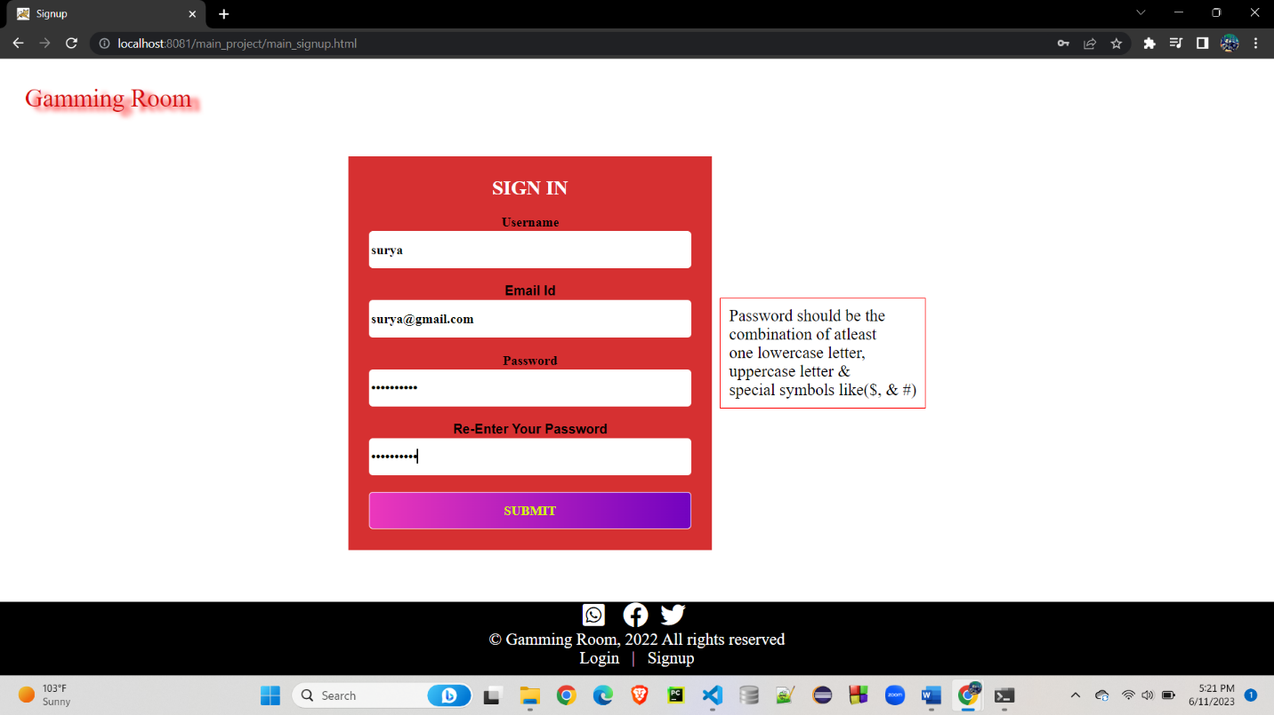

After Filling the signup form. Storing the values into the database table and page redirect to the login page.

Enter the login credentials:

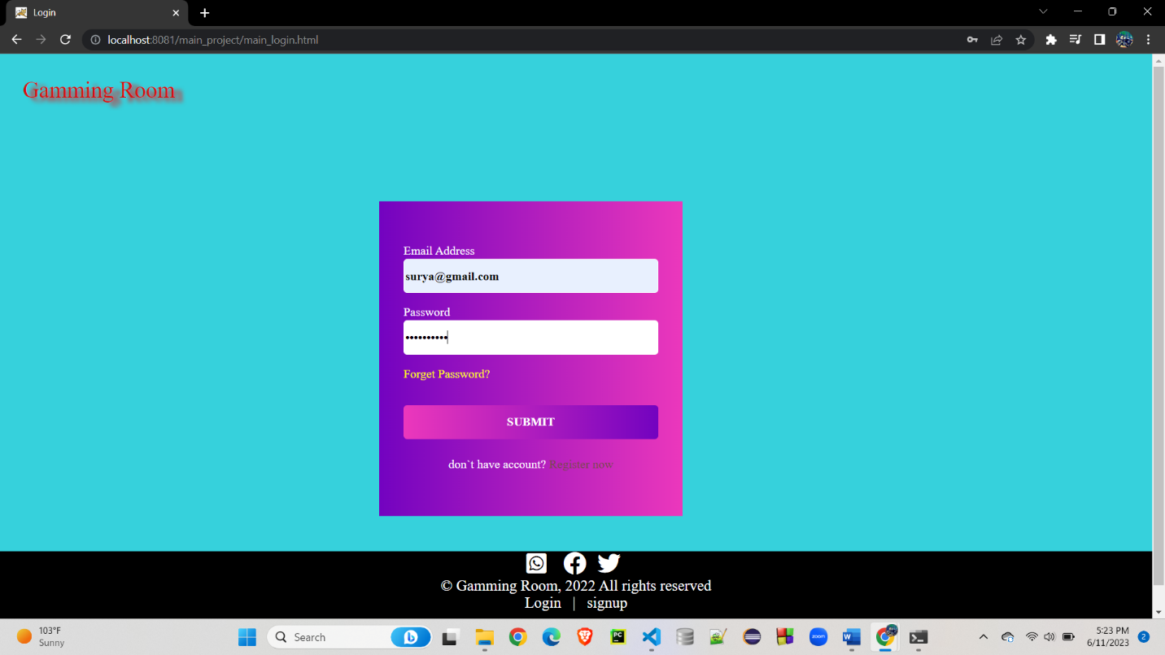

After entering the login credentials the home page will be appeared with your user name:

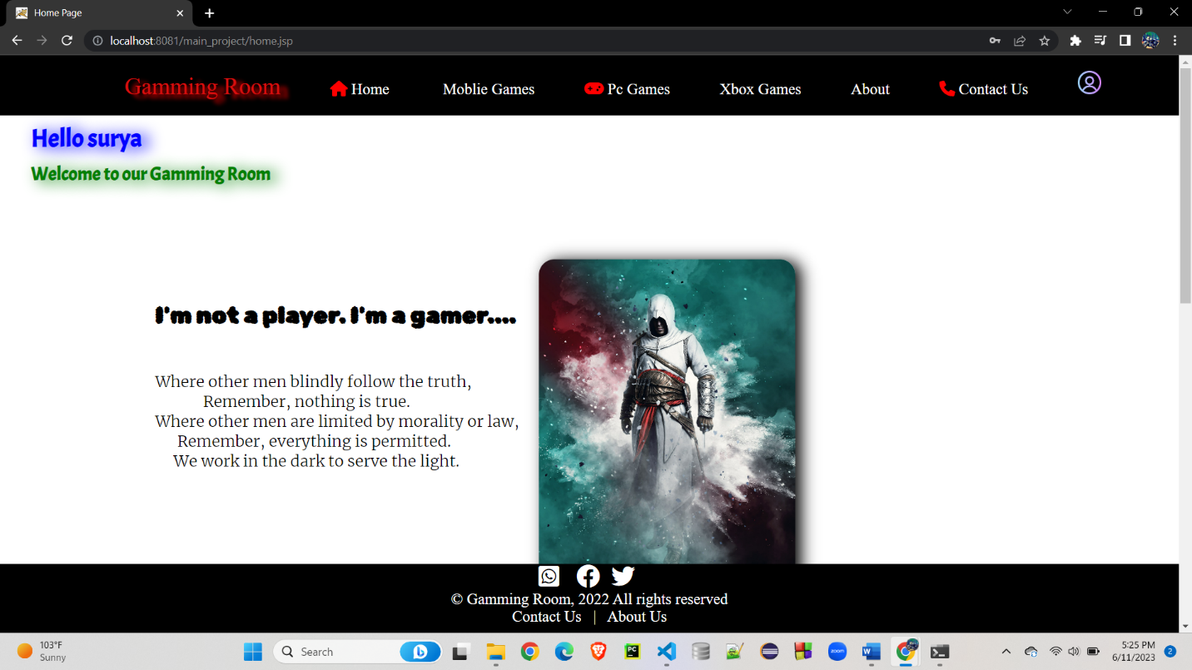

After on clicking the right top corner profile pic. You can see your personal details.

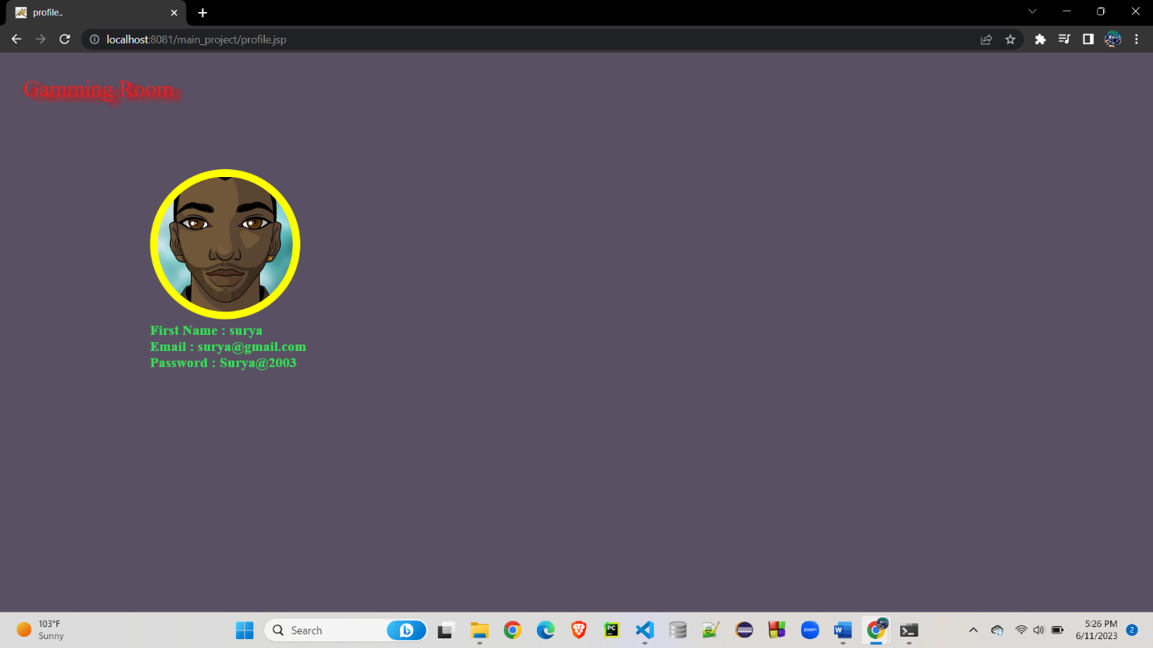

Admin can login with their credentials. And verify how users login in the website.

Admin login Credentials:

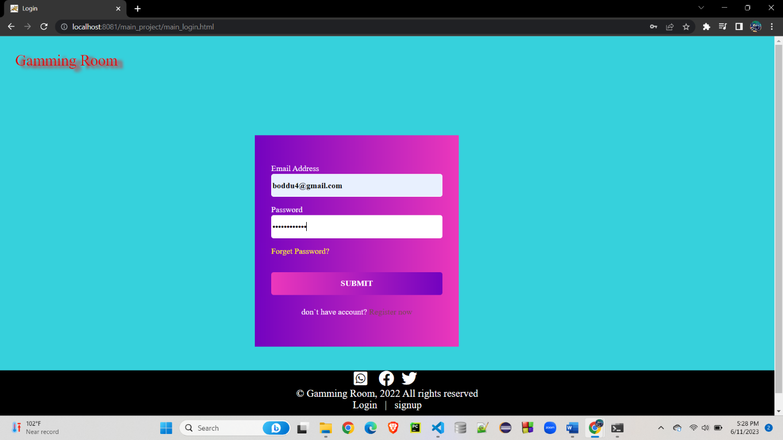

After click the Submit button:

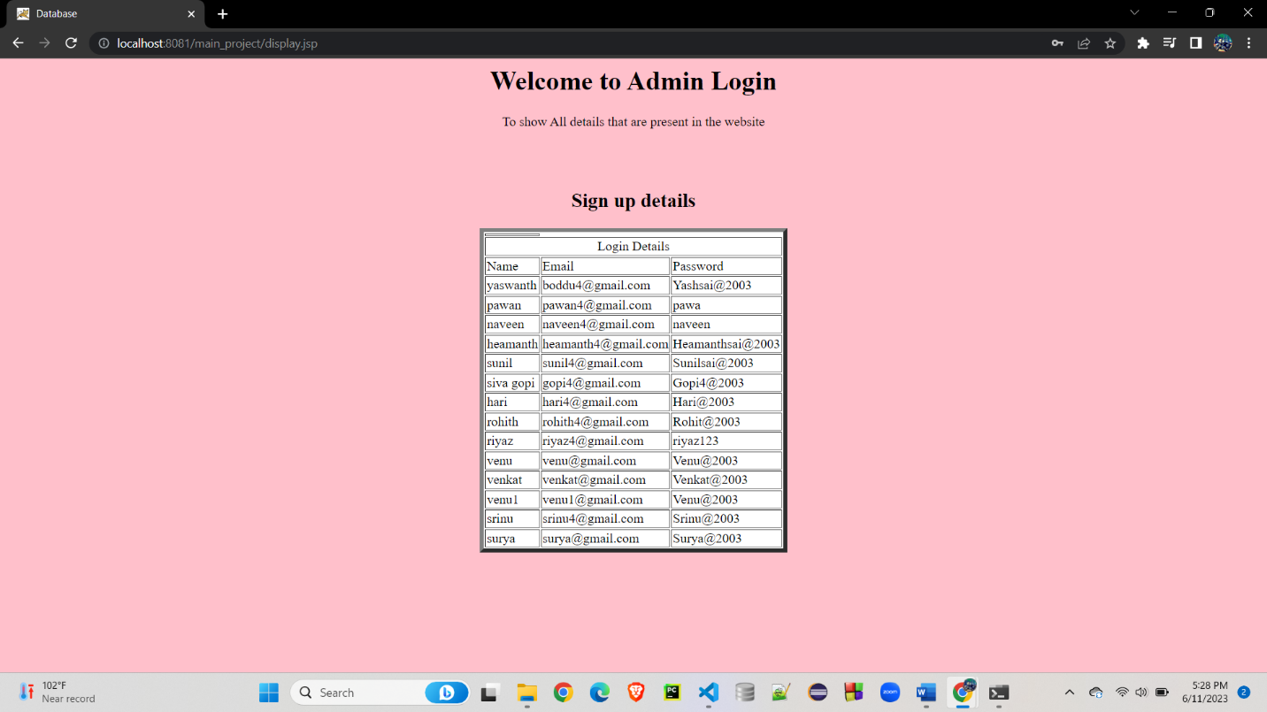

Changing the user password. Click the forgot password and user enter into reset password page and enter the required information in the form

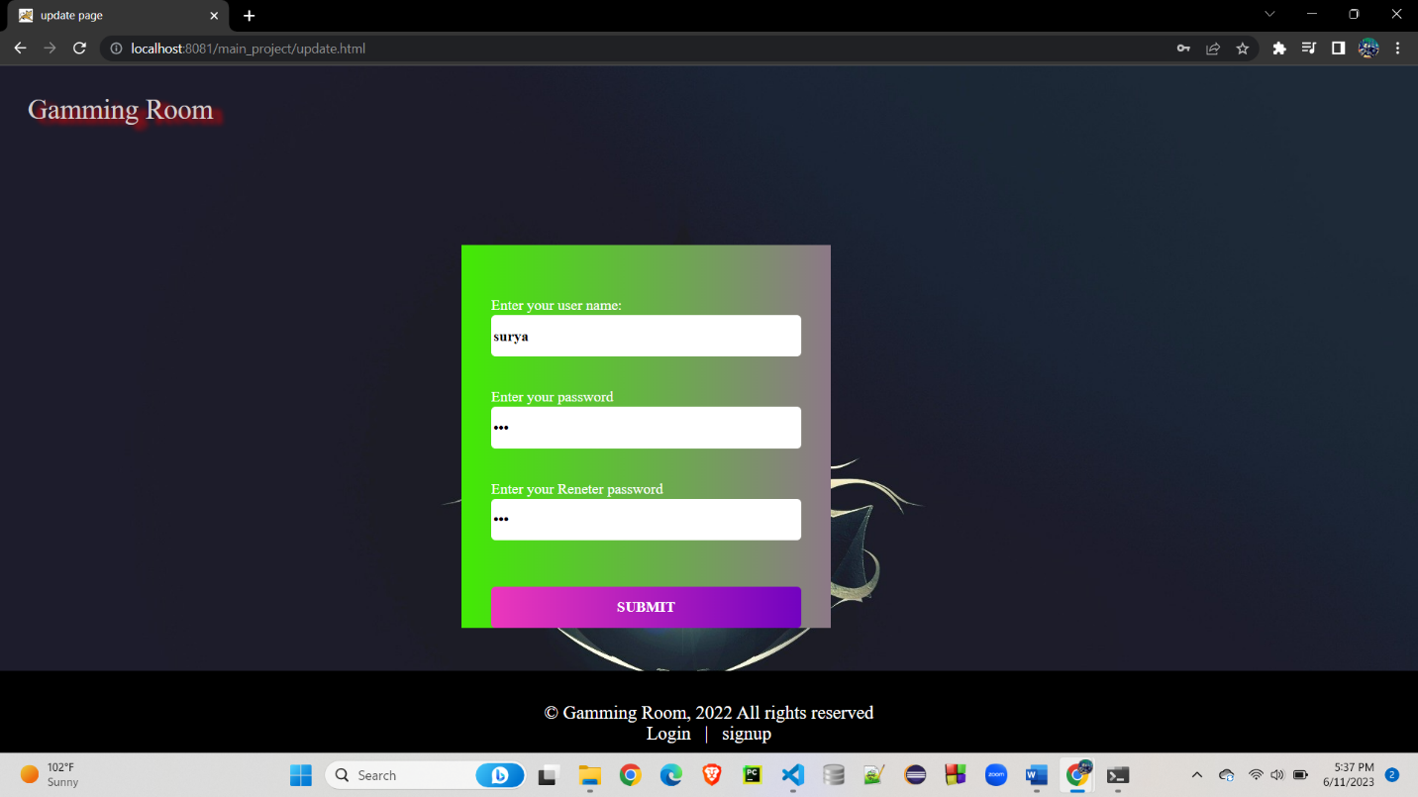

After fill the form click the submit button and page will be redirect to the login page. Enter the email and new password

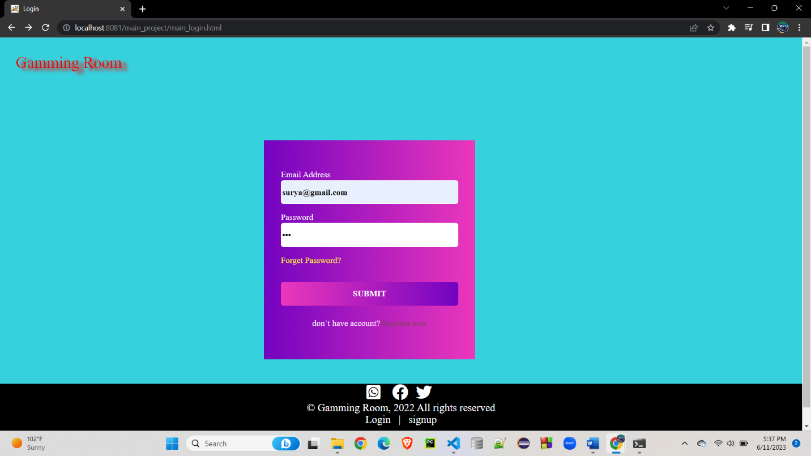

The home page will be displayed



**5.Screenshots:**

**Index Page:**

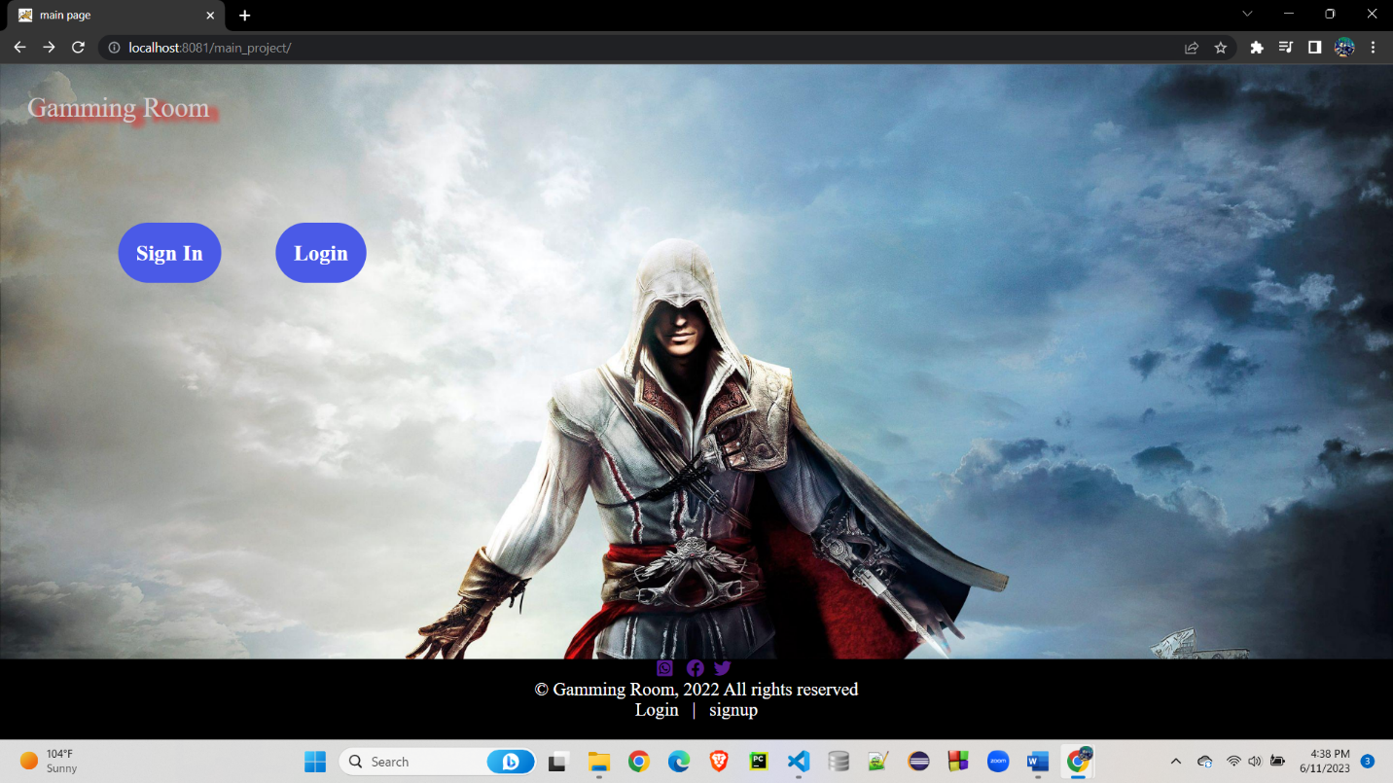

**Login Page:**

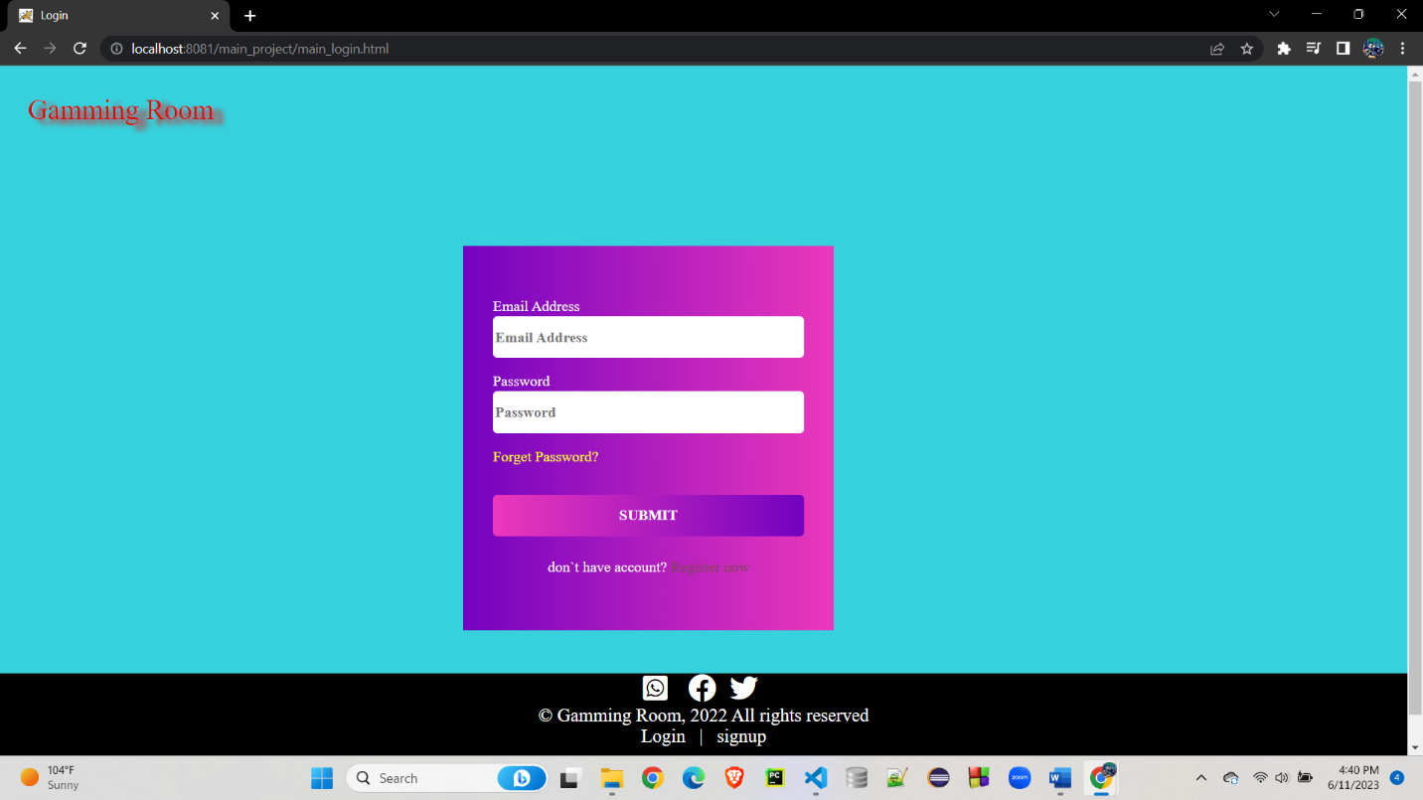

**Register Page:**

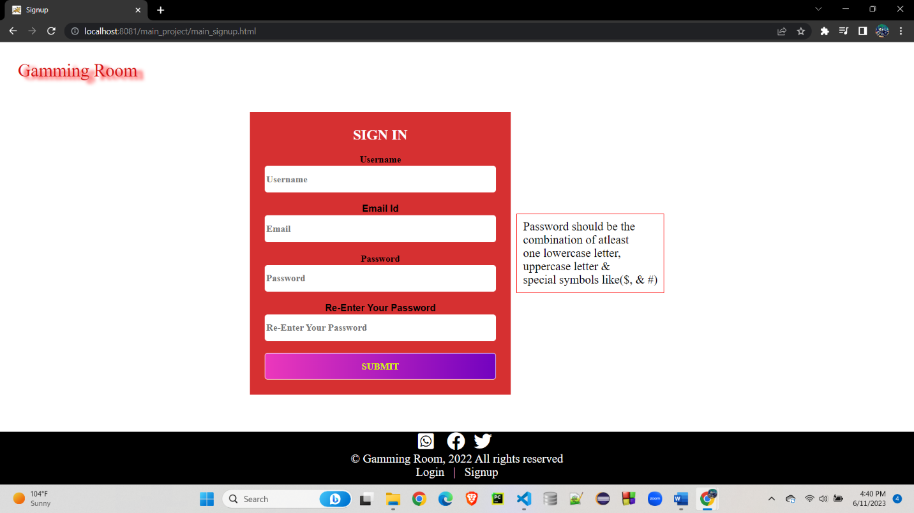

**Home Page:**

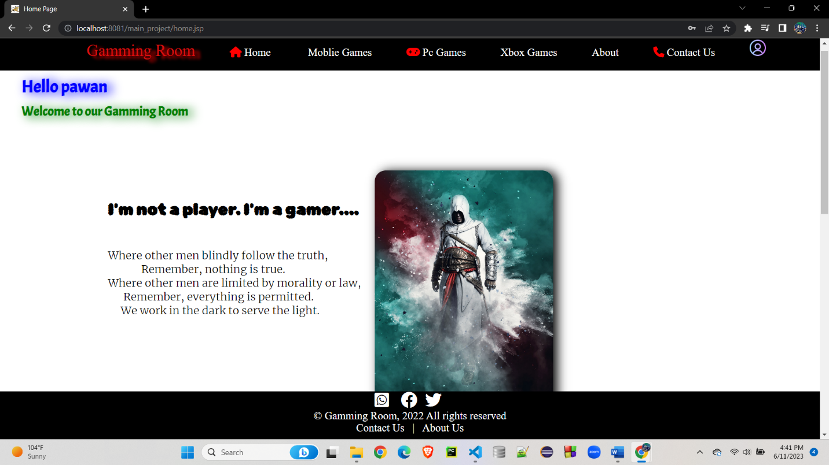

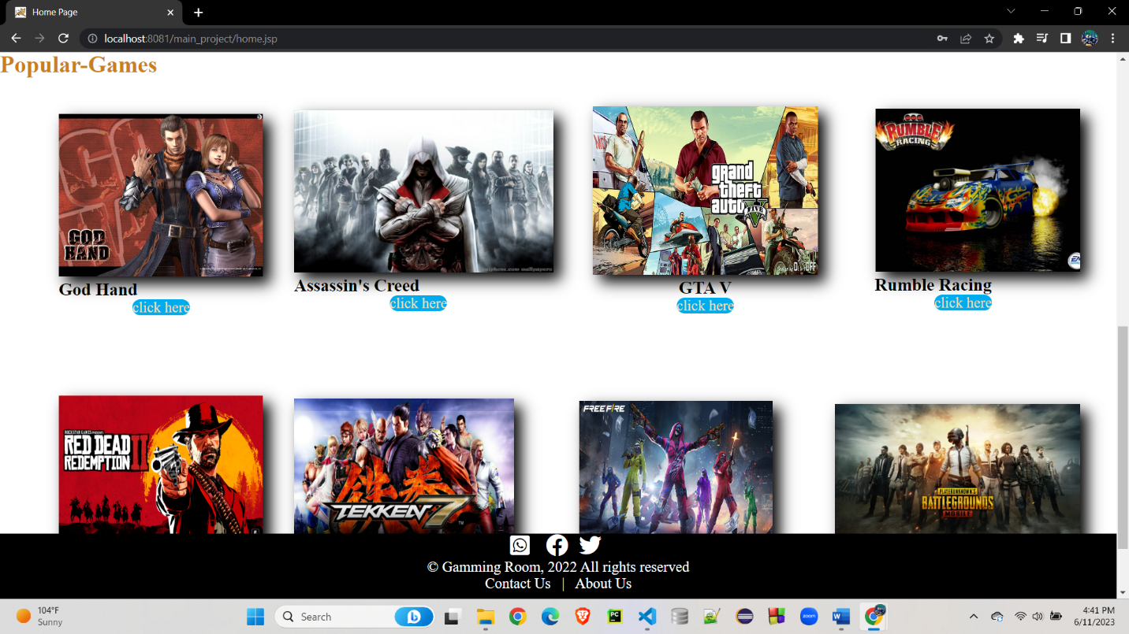

**Mobile Games Page:**

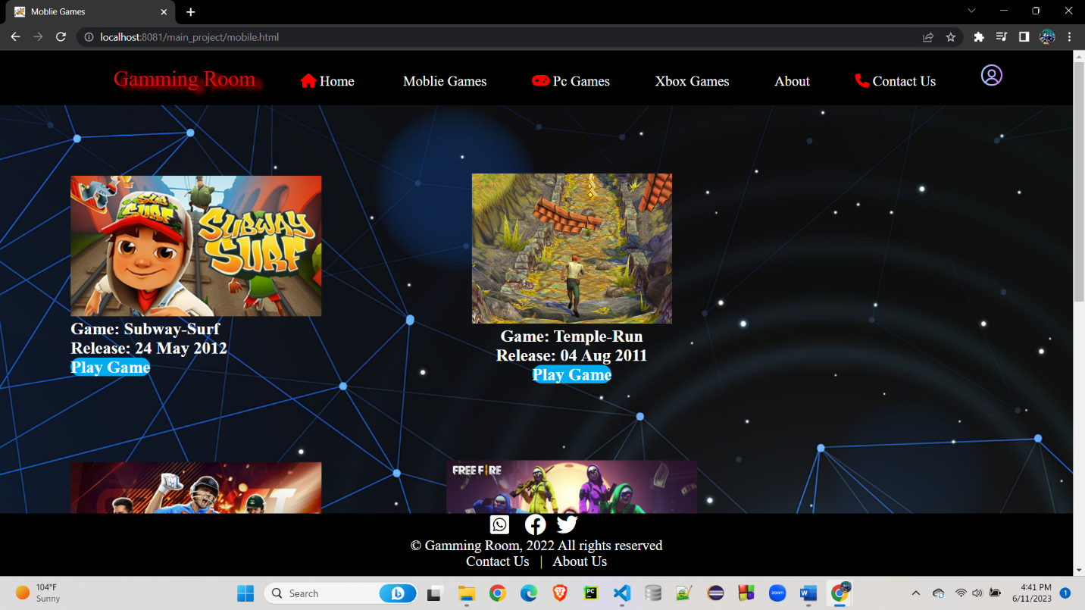

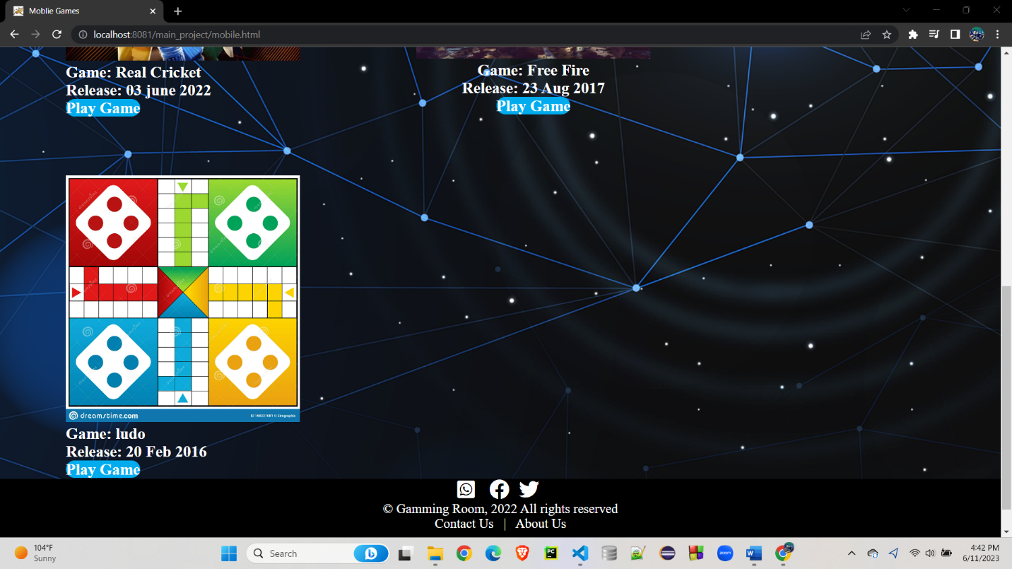

**Pc Games Page:**

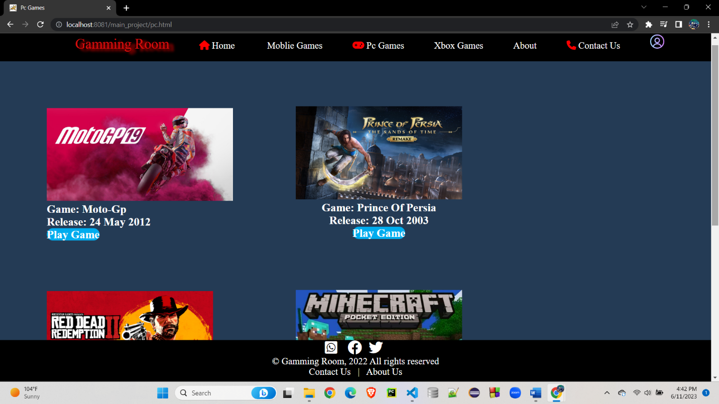

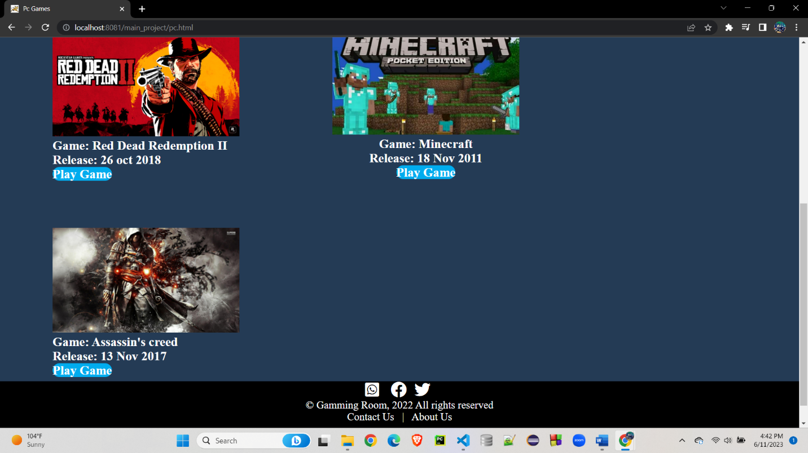

**Xbox Games Page:**

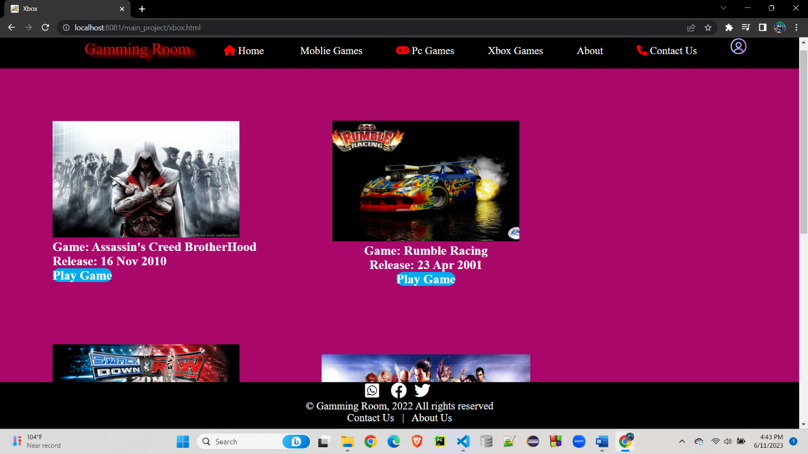

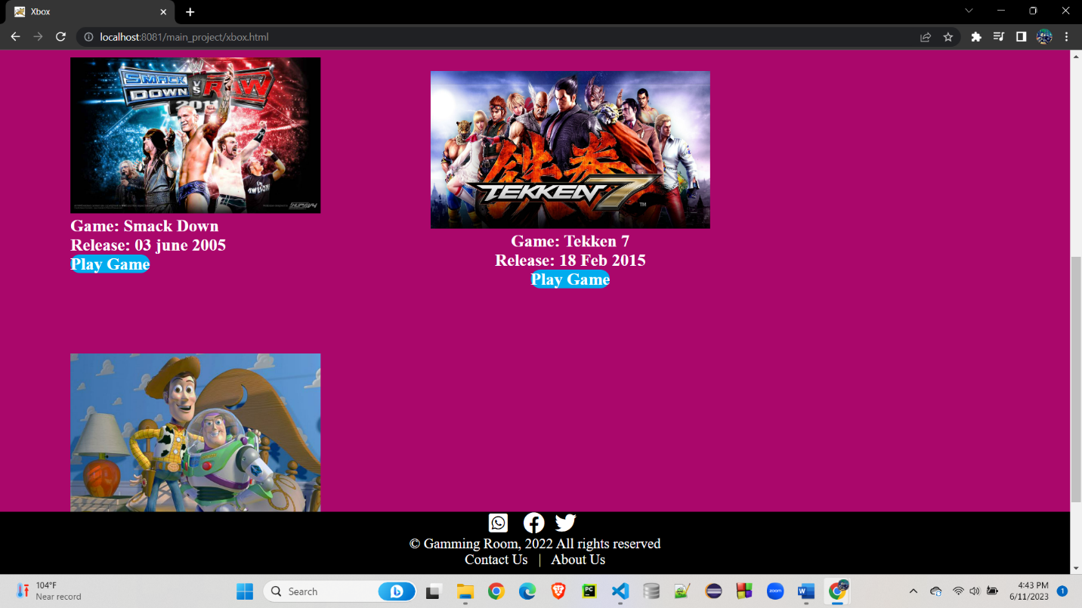

**Contact Us Page:**

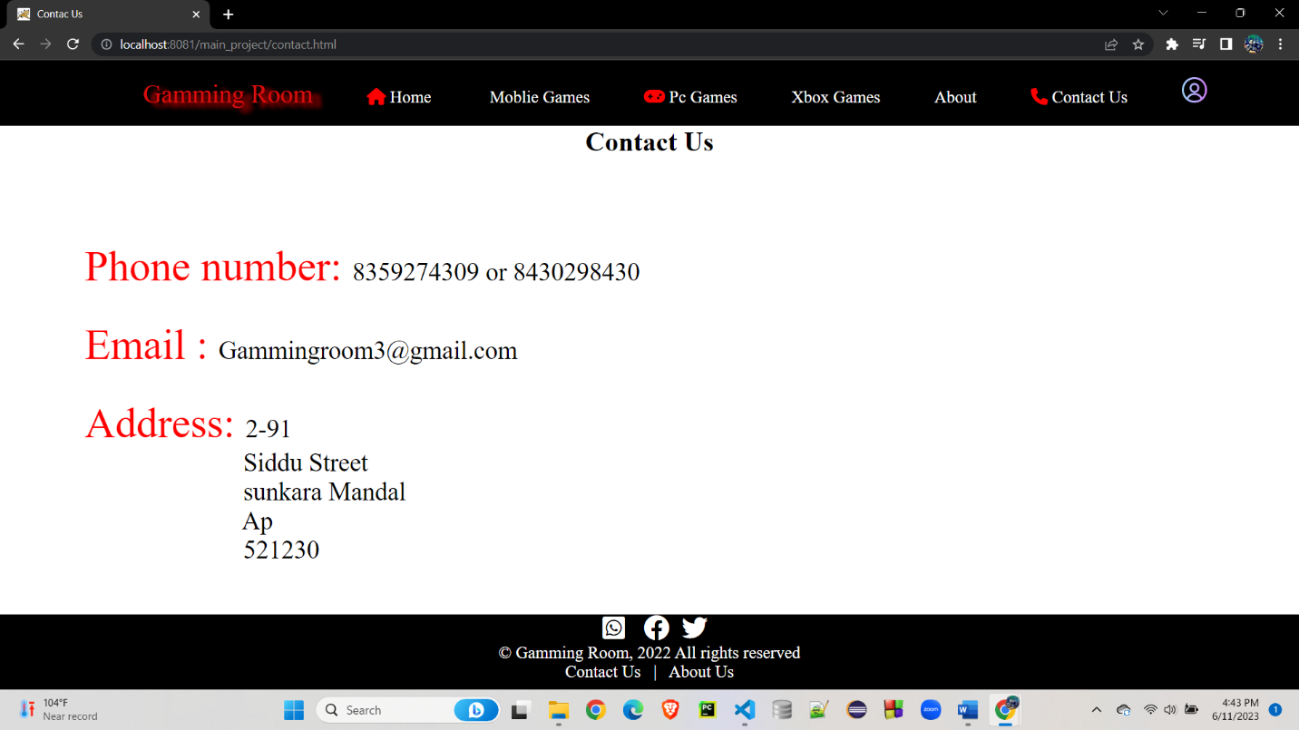

**About Page:**

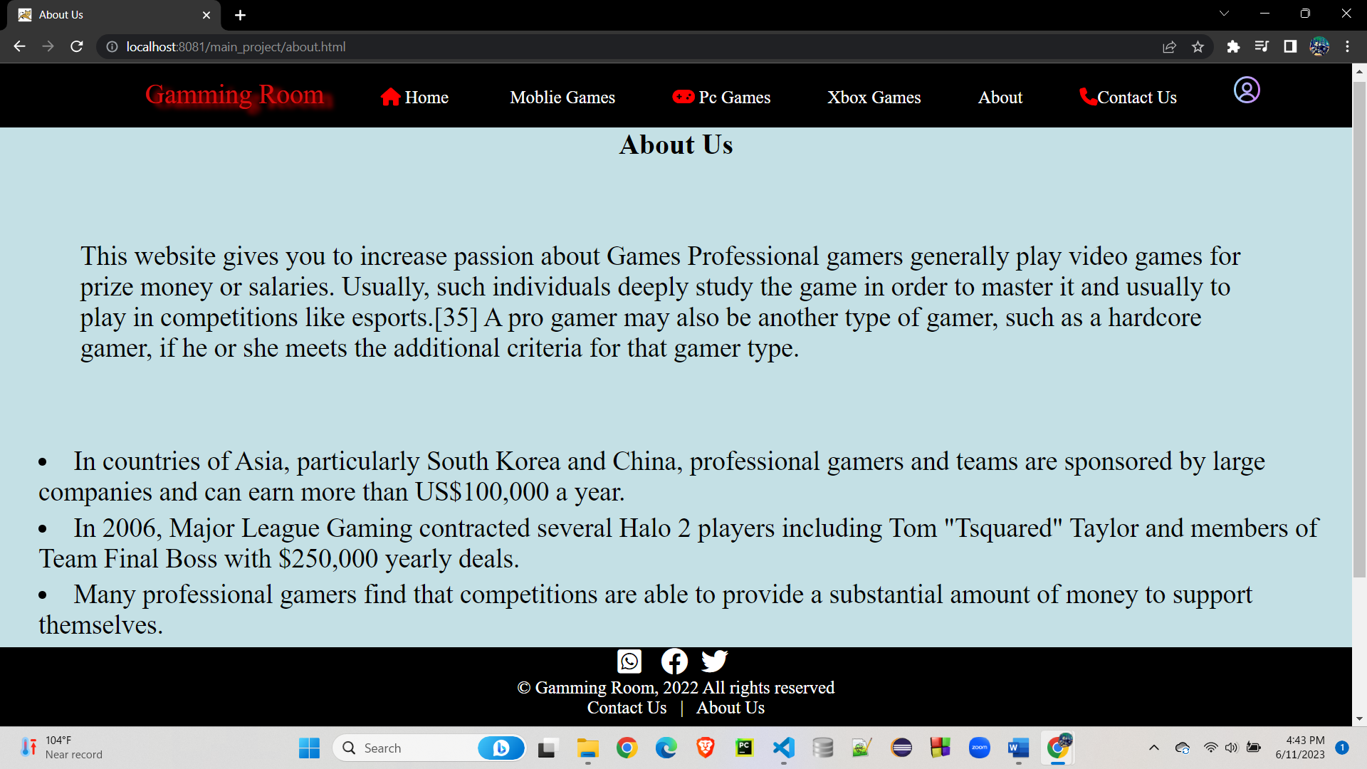

**Profile Page:**

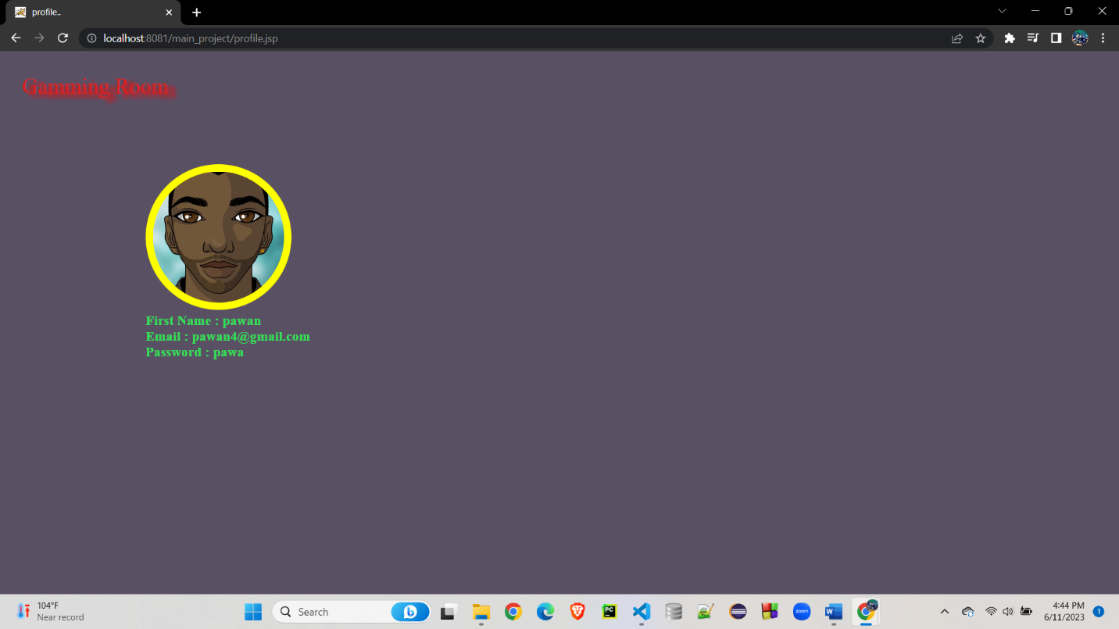

**Forgot Password Page:**

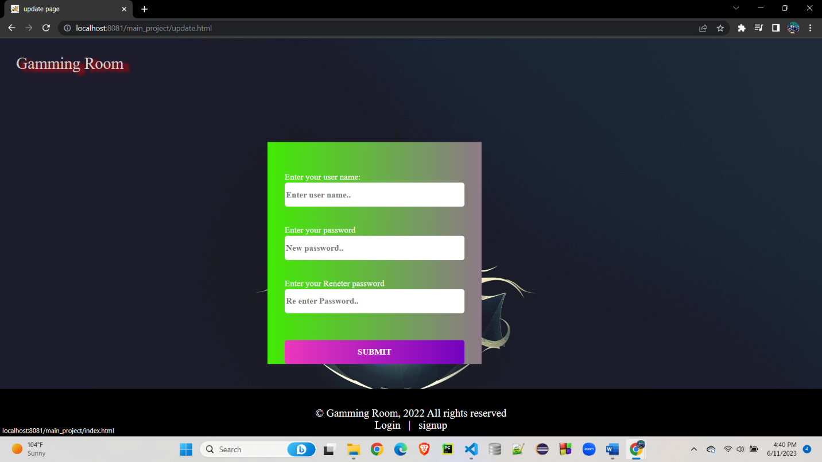

**6. Conclusion:**

*In conclusion, our gaming website is a one-stop destination for gamers of all types. With a diverse collection of games spanning multiple genres, a vibrant community, and regular updates and news, we strive to provide an immersive and enjoyable gaming experience. Our user-friendly interface and commitment to safety ensure that you can navigate our website with ease and peace of mind. Join us today and embark on a thrilling gaming journey filled with endless fun, excitement, and opportunities to connect with fellow gamers. Get ready to level up your gaming experience with our gaming website!*

**7.Web References:**

The webpage was developed by using so many networking sites and informative tutorial pages.

Some of them were listed below.

W3 SCHOOLS :  <https://www.w3schools.com/html/default.asp>

CODEPEN:  <https://codepen.io/pen/tour/welcome/start>

STACK OVERFLOW:  <https://stackoverflow.com>

JAVATPOINT: <https://www.javatpoint.com>

<https://www.geeksforgeeks.org/html>[-basics/.](https://www.geeksforgeeks.org/html-basics/)

<https://developer.mozilla.org/en>[US/docs/Learn/Getting_started_with_the_web/CSS_basics](https://developer.mozilla.org/en-US/docs/Learn/Getting_started_with_the_web/CSS_basics)

<https://online.visual-paradigm.com/drive/#infoart:proj=0&dashboard>

github – link:

<https://github.com/yaswanthbodd/gamingwebsite>